Estimating the Economic Impact of the Extended 2023 Floods in California’s Agricultural Lands
Tentative Authors List: Siddharth Kishore, Boya Zhang, Lisa Wu, J. Andres Morande, Erin Hestir, Alvar Escriva-Bou, John Abatzoglou, Joshua Viers, Josue Medellin-Azuara + others

EXECUTIVE SUMMARY
California’s agricultural systems are increasingly exposed to extreme precipitation and flooding events, particularly those associated with atmospheric rivers. While episodic flooding can provide environmental benefits such as groundwater recharge, extended inundation of cropland—especially during planting and early growth stages—can disrupt agricultural operations, reduce crop viability, and result in substantial economic losses. Despite the scale of recent flood events, consistent, field-level assessments of agricultural flood impacts remain limited, constraining the ability of agencies and stakeholders to evaluate risk, target preparedness, and design effective response strategies.
This report provides a statewide assessment of the extent and economic implications of the extended 2023 floods on California’s agricultural lands. Using a combination of satellite-derived flood detection, crop-specific planting calendars, and publicly available agricultural statistics, the analysis maps flood exposure at field scale, identifies crop vulnerability based on inundation timing and duration, and estimates potential revenue losses across major crop categories. Flood extent is derived from Sentinel-2 imagery using the Automated Water Extent Index (AWEI), calibrated and validated with high-resolution land-cover data from the Sacramento–San Joaquin Delta and applied consistently across the state.

The analysis indicates that approximately 137,000 acres of cropland experienced flooding during the 2023 events. Of this area, an estimated 79,494 acres of annual crops and 2,510 acres of perennial crops were exposed to flooding conditions likely to result in meaningful production impacts. These impacts correspond to an estimated $270 million in gross revenue losses statewide, with annual crops accounting for the vast majority of losses. Cotton, tomatoes, corn, rice, and field and grain crops experienced the largest estimated impacts, reflecting both their spatial exposure and sensitivity to extended early-season inundation.
Flood impacts were highly concentrated geographically. The southern San Joaquin Valley accounted for a disproportionate share of total losses, with Kings County alone representing more than half of the estimated statewide revenue impacts. Analysis of planted versus harvested acreage further indicates elevated crop abandonment rates in several flood-affected counties, particularly for annual crops. While planting and harvesting decisions are influenced by multiple economic and operational factors, observed patterns are consistent with the spatial and temporal distribution of flooding identified through remote sensing.
Estimated revenue losses presented in this report should be interpreted as upper-bound impacts. The analysis relies on gross revenue values and does not account for production costs, insurance indemnities, disaster assistance, or longer-term adaptive responses by growers. In addition, differences in planted acreage between reference and flood years reflect consistency with flood exposure rather than definitive causal attribution. These limitations are explicitly documented to support appropriate interpretation and use of results.

Overall, this report demonstrates the feasibility and value of integrating satellite-based flood detection with agricultural and economic data to assess flood impacts at field scale. The approach provides a transparent, replicable framework that can support post-event damage assessment, flood risk evaluation, and longer-term planning efforts. As extreme precipitation events become more frequent, such tools can help inform agricultural preparedness, infrastructure investment, and the evaluation of tradeoffs between flood damages and water management strategies, including managed aquifer recharge.

- Introduction
Globally, extreme weather disasters, such as heavy rainfall and flood events, can have immediate, and mostly negative, effects on communities, crops and consequently, on food production systems (Lesk et al. 2016). While floodwater may benefit ecosystem functions and groundwater recharge (Quandt et al. 2023), extended inundation of cropland may result in reduced crop viability and delayed or forgone crop planting, with accompanying economic consequences (Pacetti et al. 2017). Additionally, soil damage may occur if ponded water remains for prolonged periods, resulting in increased soil salinity (Welle and Mauter 2017). Yet, the economic impact of floods, which account for nearly two-thirds of recent all-weather disasters (Tellman et al. 2021), on agricultural lands is less well-documented.
The absence of field-level flooding data and self-reporting bias make it difficult to measure agricultural flow damage. Although data on revenue losses caused by floods is available in the public domain, such datasets do not adequately capture the heterogeneity at field level and thus fail to identify the impact of flooding using national data. Second, measurement bias is common since flood-induced losses are typically self-reported. With the advent of advanced technology, remote-sensed spatial data can be used to evaluate agricultural land for inundation analysis and circumvent some of the issues inherent with national data.
California has experienced frequent and intense extreme precipitation events in recent years, which have potentially impacted crops and communities. Yet, the economic impact of floods on cropland is less well-documented. This study proposes two key objectives with this in mind. Firstly, to quantify and map the extent of the flood in agricultural lands in 2023. Secondly, evaluate the gross revenue losses resulting from crop damage caused by floods and delayed or forgone crop planting. We determine a total inundation area of 137,130.7 acres across 15 major crop types and pasture; with 12,711.7 acres associated with perennial crops and 124,419 acres associated with annual crops.
In this study, we integrate remote sensing flood data and cropland and harvested area obtained from national statistics to economically evaluate the multi crop production losses in California, the largest and most diverse agricultural system state in the United States. By doing so, the contribution of the study is threefold. First, we quantify and map the extent of floods in agricultural lands. The high spatial and temporal resolution of satellite observations will greatly improve our ability to estimate the extent of floods, which are expected to increase in severity, duration and frequency in California (Albano et al. 2025; Tellman et al. 2021). Moreover, the productive regions of the world, including California’s Central Valley, will need to rely on various forms of assistance, such as financial and technological integration (Lund 2012), to effectively manage after a disaster. Importantly, the ability to map the extent of floods is the most crucial step in managing flood risk and adapting efforts. Second, we evaluate the gross revenue losses resulting from crop damage caused by floods and delayed or forgone crop planting. Finally, our study contributes to the growing literature on the integration of remote sensing products and national statistics to assess the economic effects of extreme weather disasters. Our data, which use daily satellite imagery at 20-meter resolution to estimate flood extent, allows us to take advantage of field-level flood-induced production losses, which would otherwise may be masked at the national scale and thus not be identified using national data.
Our study focuses on California, where atmospheric rivers bring about heavy rainfall and major flooding events (Dettinger et al. 2011). The roots of crops that have been inundated for an extended period can be damaged depending on the length and depth of the inundation (Jaiphong et al. 2016; Brémond et al. 2013). Different crops have different resistance to submergence during floods. Most of California’s crops are neither tolerant nor resistant to excessive irrigation and therefore can be put at risk immediately due to unintended extended periods of flooding (Albano et al. 2025). Using Sentinel satellite-derived remote-sensed data, this paper quantifies and maps the extent of flood damage to crops in California in 2023. We used crop-specific critical periods to evaluate the crops’ vulnerabilities to standing water in their life cycles. Specifically, to assess the extent of crop losses caused by flooding, we compared cropland from 2020—a normal year in terms of water supplies and planting decisions—as a reference year, and flood-induced cropland in 2023.
We find that the 2023 floods in California had a negative impact on nearly 79,494 acres of cropland associated with annual crops and 2,510 acres associated with perennial crops. This translated into a loss of $270 million in gross revenues. More specifically, we found that the flooding in California in 2023 caused the greatest crop damage in the southern part of the Central Valley. Kings County was particularly affected, with its cultivated field crops (such as tomatoes, cotton, safflower, and corn) suffering relatively more damage than perennial crops.
- Conceptual Framework
To quantify the crop-specific acreage that was impacted by the 2023 floods in California, and estimate the economic damage, we first utilized satellite-derived flooding data for the year 2023 and cropland data obtained from Land IQ for the years 2020 (comparison year) and 2023 (year of interest). Specifically, we used remote-sensed data that detects waterlogging in cropland in California that was collected every five or six days between January 1, 2023 and April 15, 2023. Second, we used a crop calendar that provides a time range for various stages of plant growth for waterlogged crops to translate flooding data into crop yield loss and thus revenue loss. Figure A1 conceptualizes this in a simple flowchart.
The probability of plant damage is determined by combining flood extent with crop-specific phenology information. For example, we assumed corn was vulnerable between April 10 and September 30. Likewise, we assumed tomatoes were vulnerable between March 15 and May 4. During this vulnerable timeframe, there is a critical period where flooding has the greatest impact. The suggestive critical period for corn is 8 days, with a critical period of 4 days for tomatoes. During these critical days, waterlogging can cause harm to crop health and result in potential crop yield loss. Similarly, we apply exclusionary thresholds for other crops based on their vulnerable, critical periods to estimate crop-specific flood damage. Table A1 presents the remaining crops and their vulnerable periods to water logging.
Two primary sources of uncertainty come to mind. The crop-specific exclusionary thresholds mentioned above may not always be applicable. In our analysis, we assume total plant damage for crops that meet the above exclusion criteria, even if their plant growth is not completely or minimally affected. Second, remote sensing-based flood data may be prone to errors, particularly in areas with crops that have very dense canopy cover. Nevertheless, we perform a battery of sensitivity tests on flood data.
- Study Area and 2023 Flood Context
  - California Central Valley
The Central Valley of California is one of the most productive agricultural regions in the United States and plays a central role in national and global food systems. Extending approximately 700 kilometers from north to south, the Valley encompasses the Sacramento Valley, San Joaquin Valley, and Tulare Basin, and supports a wide diversity of annual and perennial crops. Agricultural production in the region is enabled by extensive surface water conveyance infrastructure, groundwater pumping, and highly managed irrigation systems, much of which were designed under historical hydrologic conditions that differ from those observed today. Large portions of the Central Valley are characterized by low-lying topography, fine-grained soils, and limited natural drainage capacity, making agricultural lands particularly susceptible to prolonged inundation during extreme precipitation events. These characteristics, combined with increasing climate variability, heighten the exposure of cropland to flood-related damages.
  - The 2023 Flood Events
During the winter and early spring of 2023, California experienced a sequence of intense atmospheric river events that produced above-average precipitation across much of the state. These storms resulted in widespread flooding, particularly in the Central Valley and portions of the Sacramento–San Joaquin Delta, where soils were already saturated from earlier precipitation. Unlike short-duration flood events associated with peak river flows, the 2023 floods were characterized by extended periods of standing water and waterlogged soils, persisting for days to weeks in some agricultural areas. Such prolonged inundation coincided with critical planting and early growth stages for many annual crops, increasing the likelihood of planting delays, crop failure, or field abandonment. The timing and duration of these events distinguish the 2023 floods from historical floods and underscore their potential economic significance for agriculture.
  - Spatial heterogeneity of impacts
We aggregated the lost acreage due to flooding events in 2023 to estimate heterogeneity by county. Our estimates suggest a significant difference in agricultural land loss across counties, with Kings County losing approximately 40,000 acres and Santa Cruz County losing less than 10 acres. The Central Valley and Coastal counties are among the regions affected, with different levels of impact. Specifically, Sutter, Fresno, Colusa, Butte, and Tulare experienced the loss of agricultural areas with an area of 3001 to 6000 acres. Contra Costa, Stanislaus, Yolo, Sacramento, Glenn, San Benito, San Joaquin, Merced, and Solano experienced the loss of agricultural areas with an area of 1001 to 3000 acres. Kern, Madera, Placer, Yuba, Sonoma, and Monterey experienced the loss of agricultural land that ranged from 100 to 1000 acres. Santa Clara and Santa Cruz experienced the loss of agricultural lands that were less than 100 acres. Figure A2 shows spatial variation in the estimated actual flood damaged acreage.
- Data Sources
  - Cropland and Planting Data
Using Land IQ cropland data, contracted by the California Department of Water Resources (CDWR 2025), for the years 2020 and 2023, we find that perennial crops accounted for 4.02 million acres of cropland in California in 2023, a slight decrease of 2,710 acres from 2020. In addition, about 4.16 million acres of annual crops were planted in 2023 compared to 4.45 million acres in 2020, a decline of 293,385 acres (6.5% of total cropland in 2020).
  - Harvested Area and Production Data
Additionally, we employed USDA National Agricultural Statistics Services (NASS) crop-specific harvested areas data to estimate crop abandonment in the selected few counties that were most impacted.
  - Economic Data
We again rely on USDA NASS to obtain county-wise harvested areas and production, and statewide prices received and yield data for the years 2020-2023 to estimate economic losses for various crops that were affected during the 2023 California floods.
- Flood Detection and Mapping Methods
  - Sentinel-2 imagery and pre-processing
We used a high-resolution (~1 m) land cover map of the San Joaquin Delta between 2019 and 2022, derived from airborne hyperspectral data, as a reference to calibrate the flood detection threshold for Sentinel-2 imagery. The Delta is one of California’s most productive agricultural regions, featuring extensive croplands shaped by low-lying topography, fertile alluvial soils, and a dense network of levees and waterways. Dominant crops include corn, alfalfa, pasture, small grains, and various vegetables (Shuford et al. 2019). These crop types are representative of agriculture across the Central Valley, reflecting the region’s common climate, soil, water availability, and economic drivers (Lee et al. 2011). Consequently, the flood detection threshold derived from the San Joaquin Delta is transferable to other parts of the Central Valley.
  - AWEI Index and Threshold selection
We acquired Sentinel-2 multi-spectral imagery, including 10 m-resolution visible and near-infrared (NIR) bands, and 20 m-resolution shortwave infrared bands (SWIR1 and SWIR2). Considering the Central Valley is characterized by a flat topography, after masking cloud-covered areas, we computed the Automated Water Extent Index (AWEI) for Non-Shadow regions (referred to AWEI hereafter) using Eq. (1). Flooding areas lead to higher AWEI values. Sentinel-2 data were collected from January 1 to April 15, 2023, corresponding to the critical seedling establishment period, essential for the successful growth and survival of the plants. AWEI was calculated using equation (1):
${AWEI}_{nsh}= 4*(Green-SWIR1)$ – (0.25 * NIR + 2.75 * SWIR2) (1)
where AWEI_nsh represents Non-shadow AWEI; Green, NIR, and SWIR1, SWIR2, represent green, near-infrared, short-wave infrared bands.
  - Validation and Transferability
Using the AWEI variable, we employed a thresholding approach to map flooding extent. The optimal threshold was determined by testing against high-resolution land-cover classification datasets from the Sacramento–San Joaquin Delta, which encompass extensive wetlands and agricultural areas. These land-cover classification maps were derived from airborne spectroscopy acquisitions, and they included two flooding classes: “water” and “submerged aquatic vegetation”, with the rest of the classes considered as non-flooding. To improve the robustness of the AWEI threshold determination, we utilized annual classification products spanning 2019 to 2022. We applied a moving-window approach to identify the threshold that best captured the flooding extent. Considering that we applied a rigorous method to remove detected flooding patches of limited size (described as follows), we selected the minimum AWEI threshold across the four years to maximize the mapped flooding areas in this step.
Next, using the threshold determined in Section 2.2.3, we classified the Sentinel-2 time series for flood detection on a tile-by-tile basis. The threshold was first applied to generate binary maps distinguishing flooding from non-flooding conditions. We then applied connected-component labeling and morphological cleaning to each 2D binary mask to identify spatially coherent flood regions and remove spurious artifacts. Connected components were labeled using 4-connectivity, and regions smaller than a minimum area of 500 pixels (equivalent to 5 ha) were removed to suppress noise. The remaining regions were relabeled to ensure consistent indexing. To further enhance robustness, a morphological erosion was optionally applied, and any regions that disappeared after erosion were removed, ensuring that only structurally stable and spatially meaningful flood patches were retained. The final output is a cleaned, relabeled flood map in which each connected region has a unique identifier. Figure A3 shows flooding detection results using a thresholding approach based on AWEI for four years of spectroscopy-derived flooding products, showing both the detection accuracy (%) and the optimal threshold values.
  - Flood duration estimation
To characterize flood timing, we processed the time series from both the beginning (1 January) and the end (15 April) toward the middle of the study period, recording for each pixel the dates on which flooding was detected. This procedure yielded the first and last detection dates of flooding for each pixel, which were converted to day-of-year (DOY). Because the atmospheric river event in early 2023 affected California over an extended period, we assumed flooding to be continuous between these two dates. Flood duration was therefore calculated as the difference between the DOY of the last and first flood detections. Figure A4 shows the final flooding products: (1) Day of the year marking the first observed flooding within the study period; (2) Day of the year marking the last observed flooding within the study period; and (3) Total flooding duration (days).
- Crop Vulnerability and Damage Estimation [to be added]
  - Crop calendar and critical periods
  - Translating flooding into acreage loss
  - Planting delays versus crop failure
- Study Results
The results are divided into three sections. First, we provide a preliminary analysis of estimated production losses for specific crops affected by the 2023 California floods. Secondly, using the planted and harvested areas in 2023, we present an analysis on crop abandonment. Thirdly, we estimate revenue losses for crops caused by floods.
  - Acreage impacts by crop type
Table 1 shows (a) the 2023 planted areas, (b) the estimated acres with actual flood damage from the maximum potential flood damage, and (c) the estimated acreage loss for perennial and annual crops. Column 2 of Table 1 shows the crop-specific inundated cropland, which we define as the maximum potential flood damage. Not all waterlogged cropland results in a loss of crop yield. The estimated acres of actual flood damage to crops are shown in Column 3 of Table 1.
Table 1. Estimated Flood-Induced Acreage Damage and Revenue Loss
Selected Crop | 2023 Planted Acreage | Potential Flood Damaged Acreage | Estimated Actual Flood Damaged Acreage | Gross Revenue Per Acre (Dollars/Acre) | Estimated Revenue Loss (Thousands of Dollars)
A: Perennial Crop
Almonds | 1,513,038.1 | 7,755.2 | 2,177.1 | 2,874 | 6,257
Orchards | 308,617.4 | 626.9 | 116.1 | 8,538 | 991
Subtropical Fruit Trees | 366,998.4 | 253.9 | 161.0 | 5,149 | 829
Total Perennial Crops | 4,022,990.0 | 12,711.7 | 2,509.3 | — | 8,077
B: Annual Crop
Field and Grain | 646,706.7 | 27,614.1 | 12,747.6 | 792 | 10,096
Corn | 592,960.7 | 8,995.1 | 6,038.3 | 7,804 | 47,123
Cotton | 178,857.7 | 32,877.9 | 26,314.9 | 3,324 | 87,471
Cucurbits | 62,503.2 | 514.2 | 488.5 | 8,491 | 4,148
Rice | 523,721.5 | 22,835.2 | 14,464.0 | 1,944 | 28,118
Dry Beans | 30,544.6 | 971.8 | 971.8 | 3,017 | 2,932
Onions and Garlic | 68,269.7 | 1,575.7 | 771.9 | 10,282 | 7,936
Potatoes | 48,923.2 | 302.2 | 84.3 | 13,935 | 1,174
Tomatoes | 227,799.2 | 10,900.4 | 7,948.5 | 7,401 | 58,827
Safflower | 37,458.3 | 5,922.5 | 4,459.8 | 820 | 3,657
Truck | 165,396.0 | 912.9 | 478.2 | 13,779 | 6,589
Alfalfa | 662,132.9 | 2,446.3 | 2,027.6 | 1,014 | 2,056
Pasture | 834,952.5 | 5,719.3 | 2,698.2 | 753 | 2,032
Source: Authors’ calculations based on remote-sensed data derived from Land IQ for the year 2020 and 2023, flood data for 2023, and total value (in dollars) and harvested acreage from the 2023-2024 California Agricultural Statistics Review.
Note: The gross revenue per acre is calculated by using the total value and acres harvested. We multiply the estimated acres with actual flood damage and the gross revenue per acre to calculate the estimated revenue loss. Orchard crops include apples, apricots, avocados, sweet cherries, dates, nectarines, peaches, pears, plums, and prunes. Subtropical fruit trees include grapefruit, kiwifruit, lemons, olives, oranges, tangerines, mandarins, tangelos, and tangors. Field and grain crops are comprised of barley, corn, oats, wheat, and other field crops. Cucurbits include cucumbers, melons, cantaloupe, pumpkins, and squash. Truck crops include artichokes, broccoli, carrots, cauliflower, celery, and other vegetables.
Cotton was the most affected (26,315 acres, or 14.70% of total cotton cropland in 2020), followed by rice (14,464 acres, or 2.8%), field and grain (12,748 acres, or 1.97%), tomatoes (7,949 acres, or 3.49%), corn (6,038 acres, or 1.02%), and safflower (4,460 acres, or 11.90%). The impact on alfalfa was 2,028 acres (or less than 0.5% of total alfalfa cropland), and pasture was 2,698 acres (or 0.32%). The impact on onions, garlic, cucurbits, dry beans, potatoes, and truck crops ranged from 84 acres to 971 acres (or 0.1% to 3.2%). In total, 79,494 acres of annual crops were impacted, which translated into a loss of $262.16 million in gross revenues.
Almonds were the most affected perennial crop by 2023 flooding (2,177 acres, or 0.14% of total almond cropland in 2020), followed by subtropical fruit trees (161 acres, or 0.04%), and orchards (116 acres, or 0.04% of all orchard land). In summary, we estimate that 2,509 acres of perennial crops were harmed by the 2023 floods, which translated into a loss of %8.07 million in gross revenues. Figure 1 shows the spatial variation of estimated acreage losses across crop types caused during the 2023 flooding in California.
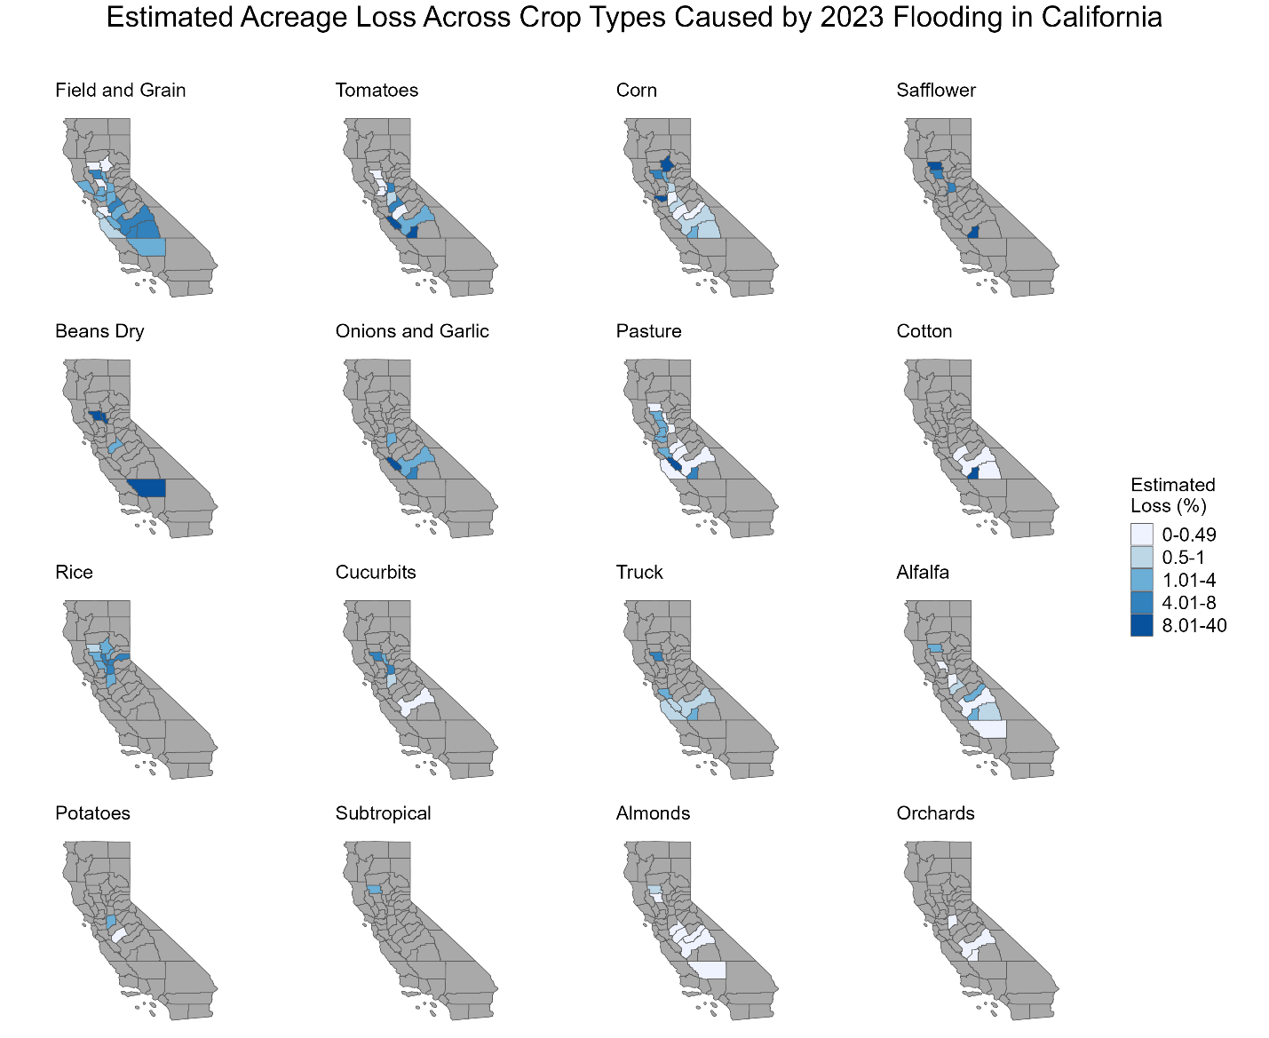
Figure 1. Estimated Acreage Loss Across Crop Types Caused by 2023 Flooding in California
Note: The estimated acreage loss is calculated by dividing the crop-specific acres lost by the planted acreage in that county. The minimum non-zero loss is slightly less than 0.5% and the maximum loss is 40%.

  - Revenue impacts
Next, we present the estimated revenue losses for each crop type in column 5 of Table 1. The gross revenue per acre is calculated by using the total value (in dollars) and acres harvested obtained from the 2023-2024 California Agricultural Statistics Review. Then, we multiply the estimated acres with actual flood damage and the gross revenue per acre to calculate the estimated revenue loss. We estimate the total economic damage caused by flooding to annual crops at $262.16 million. The agricultural crops that suffered the highest revenue losses include cotton ($87.5 million), tomatoes ($58.8 million), corn ($47.1 million), rice ($28.1 million), and field and grains ($10 million). Alfalfa, cucurbits, dry beans, garlic, onions, pasture crops, potatoes, safflower, and truck crops are estimated to have losses in the range of $1 million to $8 million.
Flooding to perennial crops had an estimated economic damage of $8.08 million. Almonds account for the highest estimated revenue loss, at nearly $6.3 million, followed by orchards and subtropical fruit trees, which account for approximately $1 million and $0.8 million, respectively.
Column 4 shows the gross revenue per acre. It is worth noting that our revenue loss estimates are based on flooded, uncultivated land that was not planted in 2023 but was planted in 2020, hence it may overestimate losses, as these are not profits per acre.
Figure 2 shows the estimated revenue loss by county across crop types due to heavy rainfall and flooding events in California in 2023. Kings County experienced an estimated flood-induced revenue loss of $144.7 million (6.7% of the total agricultural output of Kings County in 2023) across alfalfa, corn, cotton, field and grain, onions and garlic, orchards, pasture, safflower, tomatoes, and truck crops. Fresno County experienced an estimated revenue loss of $22.1 million across alfalfa, almonds, corn, cotton, cucurbits, field and grain, onions and garlic, orchards, pasture, tomatoes, and truck crops.
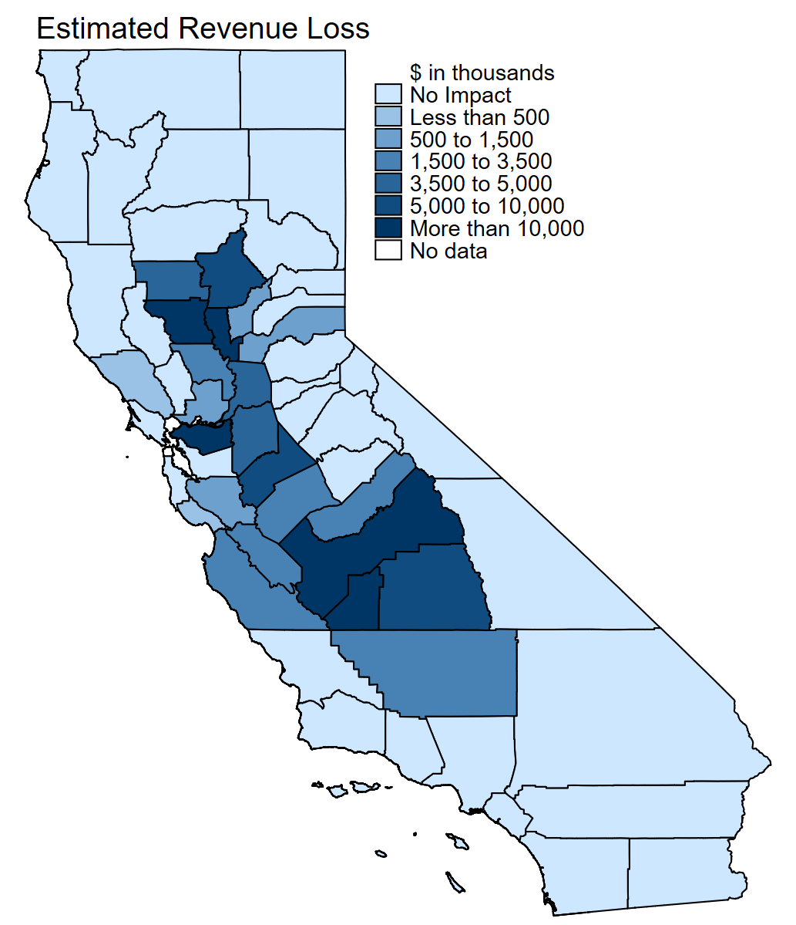
Figure 2. Estimated Economic Loss Across Crop Types Caused by 2023 Flooding in California
Contra Costa, Colusa, Sutter, and Butte counties experienced an estimated revenue loss of $18.1 million, $12.5 million, $12.1 million, and $8.6 million, respectively, across corn, field and grain, almonds, rice, tomatoes, dry beans, and cucurbits. Tulare County experienced an estimated revenue loss of $8.3 million across alfalfa, corn, cotton, and field and grain crops. Stanislaus County experienced an estimated revenue loss of $7.5 million across alfalfa, almonds, dry beans, corn, tomatoes, pasture, and field and grain crops.
The revenues lost in Madera, Yolo, Merced, San Benito, Glenn, Sacramento, and San Joaquin counties ranged from $3 million to $5 million across, almonds, corn, cotton, field and grain, potatoes, tomatoes, pasture, rice, safflower, onions and garlic, and truck crops. Placer, Solano, Kern, and Monterey counties experienced an estimated revenue loss of between $1 and $2 million. The estimated revenue loss for Sonoma, Santa Clara, and Yuba counties was less than $1 million.
In sum, the 2023 floods in California had a negative impact on less than 0.1% of cropland (2,509.3 acres out of 4.02 million acres) associated with perennial crops. However, 1.79% (79,493.6 acres out of 4.45 million acres) of annual crops were harmed by the 2023 floods, suggesting planting locations could be more vulnerable to extended flooding or excessive waterlogging. While 2020 was a normal year, a comparison of acreage between 2020 and 2023 does not necessarily mean the difference is due to flooding. Many other unobservable factors are likely also affecting the planting decisions in both years.
  - Crop abandonment rate
Table 2 presents the abandonment rate for selected crops, including corn, cotton, rice, and processed tomatoes, using harvested and planted areas due to floods in selected counties during the 2023 floods. We obtained planted and harvested areas for selected flood-induced crops in 2023 from the California’s County Agricultural Commissioner’s Report to calculate the abandonment rate, which measures the percentage of unharvested acres compared to total planted acres. While the cause for any losses cannot be certainly attributed to flood impacts, we do use this abandonment rate to verify crop damages from waterlogging. Extreme precipitation events in 2023 affected the largest corn production in the Sacramento Valley (Glenn and Sacramento counties) and the southern Central Valley (San Joaquin County). Additionally, the abandonment rate for corn, processing tomatoes, and cotton is significant; slightly more than half of cotton crops were abandoned in Glenn County, while one-sixth of cotton crops and one-tenth of tomato plants were abandoned in Fresno County. More than one-tenth of processed tomatoes were abandoned in Stanislaus County.
Table 2. Selected Crop Abandonment in Selected Affected Counties
Selected  Crop | Selected County | Planted  Acre | Harvested  Acre | Abandonment Rate
 |  | (1) | (2) | (3) = 1 – (2)/(3)
Corn | Glenn | 4,700 | 2,170 | 0.538
 | Sacramento | 13,300 | 8,730 | 0.344
 | San Joaquin | 33,600 | 24,100 | 0.283
Cotton | Fresno | 30,200 | 28,300 | 0.063
 | Kings | 33,000 | 32,200 | 0.024
 | Merced | 18,200 | 18,100 | 0.005
 | Tulare | 1,600 | 1,590 | 0.006
Rice | Colusa | 135,000 | 134,000 | 0.007
 | Glenn | 75,500 | 75,200 | 0.004
 | San Joaquin | 10,000 | 9,900 | 0.010
 | Sutter | 109,000 | 108,500 | 0.005
 | Yuba | 34,600 | 34,400 | 0.006
Processing Tomatoes | Colusa | 15,900 | 15,700 | 0.013
 | Fresno | 71,400 | 64,500 | 0.097
 | Glenn | 1,550 | 1,520 | 0.019
 | Kern | 16,600 | 16,000 | 0.036
 | Kings | 16,600 | 15,800 | 0.048
 | Madera | 5,900 | 5,600 | 0.051
 | Merced | 2,8100 | 27,700 | 0.014
 | San Joaquin | 22,200 | 20,700 | 0.068
 | Solano | 17,300 | 17,000 | 0.017
 | Stanislaus | 10,700 | 9,400 | 0.121
 | Sutter | 12,200 | 12,100 | 0.008
 | Yolo | 35,200 | 33,800 | 0.040
 | Yuba | 40 | 30 | 0.250
Note: Planted and harvested areas were obtained from the USDA NASS County estimate for 2023.
- Discussion
The results of this study indicate that extended flooding in 2023 disproportionately affected annual crops in California, both in terms of acreage impacted and associated revenue losses. This pattern reflects the greater sensitivity of annual cropping systems to planting delays and early-season inundation, as well as the limited flexibility growers have to recover lost production once critical planting windows have passed. Perennial crops, while exposed to flooding, experienced comparatively smaller proportional losses, suggesting a degree of resilience to short-term inundation. The spatial concentration of damages in the southern San Joaquin Valley underscores the interaction between climate extremes, landscape characteristics, and cropping patterns. These findings highlight the importance of integrating flood risk into agricultural planning and infrastructure management, particularly as extreme precipitation events become more frequent under climate change.
- Limitations and Uncertainty [in process]
While this study provides a spatially explicit and internally consistent estimate of flood-induced agricultural damages in California during 2023, several limitations and sources of uncertainty should be acknowledged when interpreting the results. These limitations arise from data availability, methodological assumptions, and the inherent complexity of attributing agricultural outcomes to extreme weather events.
A first limitation relates to the use of gross revenue as a measure of economic loss. Gross revenue reflects the value of production at the farm gate but does not account for variable input costs, fixed costs, crop insurance indemnities, disaster assistance payments, or adaptive management decisions by growers. As a result, estimated revenue losses should be interpreted as upper-bound measures of potential economic impact rather than realized net income losses. In practice, some growers may partially offset revenue losses through insurance payouts or cost savings associated with unplanted or abandoned acreage. Nevertheless, gross revenue remains a widely used and transparent metric for comparing impacts across crops and regions and is appropriate for statewide assessments where detailed cost data are unavailable.
A second source of uncertainty arises from the counterfactual comparison between 2020 and 2023 cropland patterns. Although 2020 is treated as a representative year with relatively normal water supply conditions, differences in planted acreage between 2020 and 2023 cannot be attributed solely to flooding. Market conditions, input prices, labor availability, groundwater pumping constraints, and regulatory changes may also influence planting decisions. Consequently, reductions in planted acreage identified in this study should be interpreted as consistent with flood-related impacts rather than definitive causal estimates. This limitation is particularly relevant for annual crops, where planting decisions are more flexible and responsive to short-term conditions.
Third, uncertainty is inherent in the remote sensing–based detection of flooding. Although Sentinel-2 imagery provides relatively high spatial and temporal resolution, classification errors may occur due to shallow inundation or confusion between standing water and saturated soils. While the Automated Water Extent Index (AWEI) and calibration using high-resolution Delta land-cover data improve detection accuracy, some flooded areas may be missed (false negatives) and some non-flooded areas may be incorrectly classified as flooded (false positives). Sensitivity analyses conducted as part of this study indicate that results are robust to reasonable variations in flood detection thresholds, but classification uncertainty cannot be fully eliminated. In particular, because the Delta may have limited coverage of orchard land cover, the AWEI thresholding approach could result in reduced accuracy over orchards in the Central Valley. Additional field-based or airborne data are needed for further validation.”
A fourth limitation concerns assumptions about flood duration and continuity. Flood duration was estimated using the first and last detection dates of inundation during the study period, with the assumption that flooding persisted continuously between these dates. In reality, flooding conditions may fluctuate, with intermittent drainage or partial drying between satellite overpasses. This assumption may overestimate flood duration in some locations, potentially leading to conservative estimates of damage. Conversely, short-duration flooding events that occur between satellite overpass observations may not be fully captured, leading to underestimation of impacts in some cases. The net effect of these opposing biases is difficult to quantify but should be considered when interpreting results.
Fifth, the translation of flooding into crop damage relies on crop-specific vulnerable periods and critical thresholds derived from agronomic literature and planting calendars. While these thresholds reflect best available knowledge, actual crop tolerance to inundation may vary depending on soil type, drainage conditions, cultivar characteristics, and management practices. The assumption that crops exceeding critical thresholds experience complete loss simplifies a complex biological response and may overstate damage in cases where partial recovery is possible. As such, estimated acreage losses represent potential damage rather than precise yield outcomes.
Finally, this analysis focuses on direct impacts to crop acreage and gross revenue and does not capture broader economic or environmental effects of flooding. Indirect impacts such as disruptions to farm labor, processing facilities, transportation infrastructure, and local economies are not considered. Similarly, longer-term effects of flooding on soil quality, salinity, and future productivity are beyond the scope of this study but may have important implications for agricultural resilience. Conversely, potential benefits of flooding, such as groundwater recharge or soil nutrient deposition, are not explicitly quantified and may offset some negative impacts over longer time horizons.
Despite these limitations, the approach presented in this study offers a transparent and scalable framework for assessing agricultural flood impacts using publicly available data. By combining remote sensing, crop calendars, and agricultural statistics, the analysis provides insights that are difficult to obtain using traditional reporting mechanisms alone. Future work could reduce uncertainty by integrating field-level observations, crop insurance data, and econometric attribution methods, as well as by extending the framework to evaluate tradeoffs between flood damage and managed aquifer recharge under alternative water management strategies.
- Conclusions and Policy Implications
The Central Valley of California is becoming more susceptible to floods, and remote-sensed spatial data can be used to evaluate agricultural lands for inundation analyses and thus strengthen preparedness in the future (Albano et al. 2025). Here, we quantify and map the loss of acreage due to flooding in California in 2023. Our research on statewide crop loss due to the 2023 floods showed that extended flooding had a negative impact on roughly 82,000 acres—79,494 acres of annual crops (out of 4.45 million acres statewide) and 2,509 acres of perennial crops (out of 4.02 million acres statewide). These flood-induced crop losses translated into an estimated loss of $270.23 million in gross revenues. Of this, $262.16 million was associated with annual crops and $8.08 million was associated with perennial crops.
Almonds, cotton, tomatoes, and rice crops account for the greatest revenue losses. A significant portion of the damage was concentrated in the San Joaquin Valley, the largest and most productive agricultural region in the United States. Our results highlight the importance of managing for climate extremes, including floods, and the strategic use of excess water for managed aquifer recharge. This we leave for future research.

- References
Albano, Christine M., Christopher E. Soulard, Blake A. Minor, et al. 2025. “Assessing Causes and Consequences of Winter Surface Water Dynamics in California’s Central Valley Using Satellite Remote Sensing.” Journal of Flood Risk Management 18 (2): e70080. https://doi.org/10.1111/jfr3.70080.
Brémond, P., F. Grelot, and A.-L. Agenais. 2013. “Review Article: Economic Evaluation of Flood Damage to Agriculture – Review and Analysis of Existing Methods.” Natural Hazards and Earth System Sciences 13 (10): 2493–512. https://doi.org/10.5194/nhess-13-2493-2013.
CDWR. 2025. “Statewide Crop Mapping, 2014 - 2023.” Version California Department of Water Resources, CA. https://gis.water.ca.gov/app/CADWRLandUseViewer/.
Dettinger, Michael D., Fred Martin Ralph, Tapash Das, Paul J. Neiman, and Daniel R. Cayan. 2011. “Atmospheric Rivers, Floods and the Water Resources of California.” Water 3 (2): 445–78. https://doi.org/10.3390/w3020445.
Jaiphong, Thanankorn, Jun Tominaga, Kenta Watanabe, et al. 2016. “Effects of Duration and Combination of Drought and Flood Conditions on Leaf Photosynthesis, Growth and Sugar Content in Sugarcane.” Plant Production Science 19 (3): 427–37. https://doi.org/10.1080/1343943X.2016.1159520.
Lee, Juhwan, Steven De Gryze, and Johan Six. 2011. “Effect of Climate Change on Field Crop Production in California’s Central Valley.” Climatic Change 109 (S1): 335–53. https://doi.org/10.1007/s10584-011-0305-4.
Lesk, Corey, Pedram Rowhani, and Navin Ramankutty. 2016. “Influence of Extreme Weather Disasters on Global Crop Production.” Nature 529 (7584): 84–87. https://doi.org/10.1038/nature16467.
Lund, Jay R. 2012. “Flood Management in California.” Water 4 (1): 157–69. https://doi.org/10.3390/w4010157.
Pacetti, Tommaso, Enrica Caporali, and Maria Cristina Rulli. 2017. “Floods and Food Security: A Method to Estimate the Effect of Inundation on Crops Availability.” Advances in Water Resources 110 (December): 494–504. https://doi.org/10.1016/j.advwatres.2017.06.019.
Quandt, Amy, Ashley E. Larsen, Gracie Bartel, Kiana Okamura, and Daniel Sousa. 2023. “Sustainable Groundwater Management and Its Implications for Agricultural Land Repurposing.” Regional Environmental Change 23 (4): 120. https://doi.org/10.1007/s10113-023-02114-2.
Shuford, W. David, Matthew Reiter, Kristin Sesser, Catherine Hickey, and Gregory Golet. 2019. “The Relative Importance of Agricultural and Wetland Habitats to Waterbirds in the Sacramento–San Joaquin River Delta of California.” San Francisco Estuary and Watershed Science 17 (1). https://doi.org/10.15447/sfews.2019v17iss1art2.
Tellman, B., J. A. Sullivan, C. Kuhn, et al. 2021. “Satellite Imaging Reveals Increased Proportion of Population Exposed to Floods.” Nature 596 (7870): 80–86. https://doi.org/10.1038/s41586-021-03695-w.
Welle, Paul D, and Meagan S Mauter. 2017. “High-Resolution Model for Estimating the Economic and Policy Implications of Agricultural Soil Salinization in California.” Environmental Research Letters 12 (9): 094010. https://doi.org/10.1088/1748-9326/aa848e.

Appendix Figure and Table

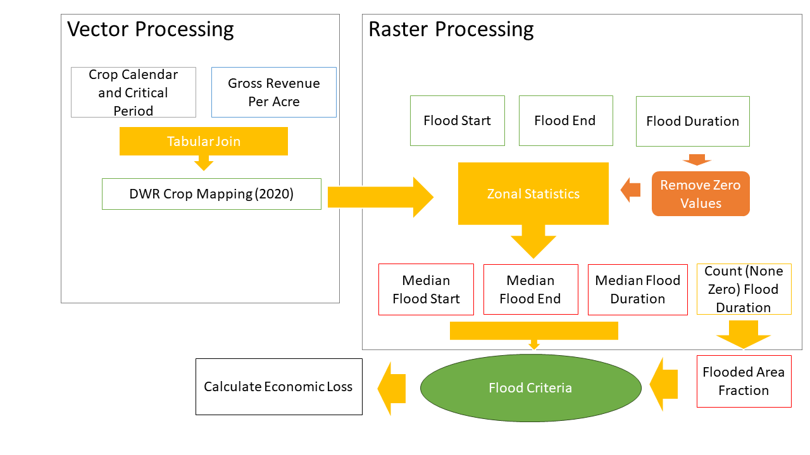
Figure A1. A simple conceptual framework.

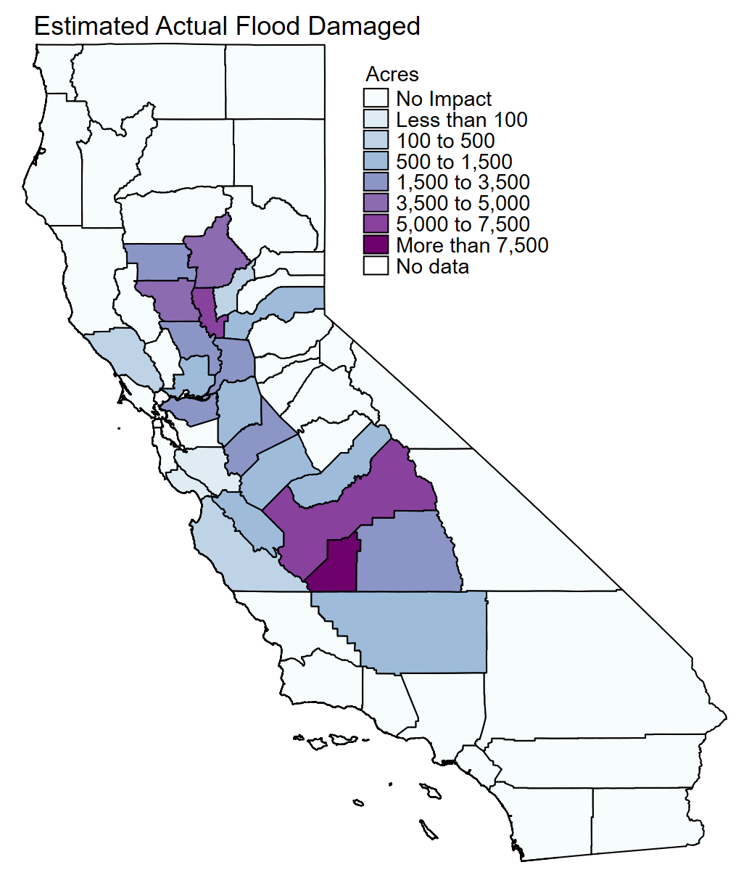
Figure A2. Spatial variation in the estimated actual flood damaged acreage.
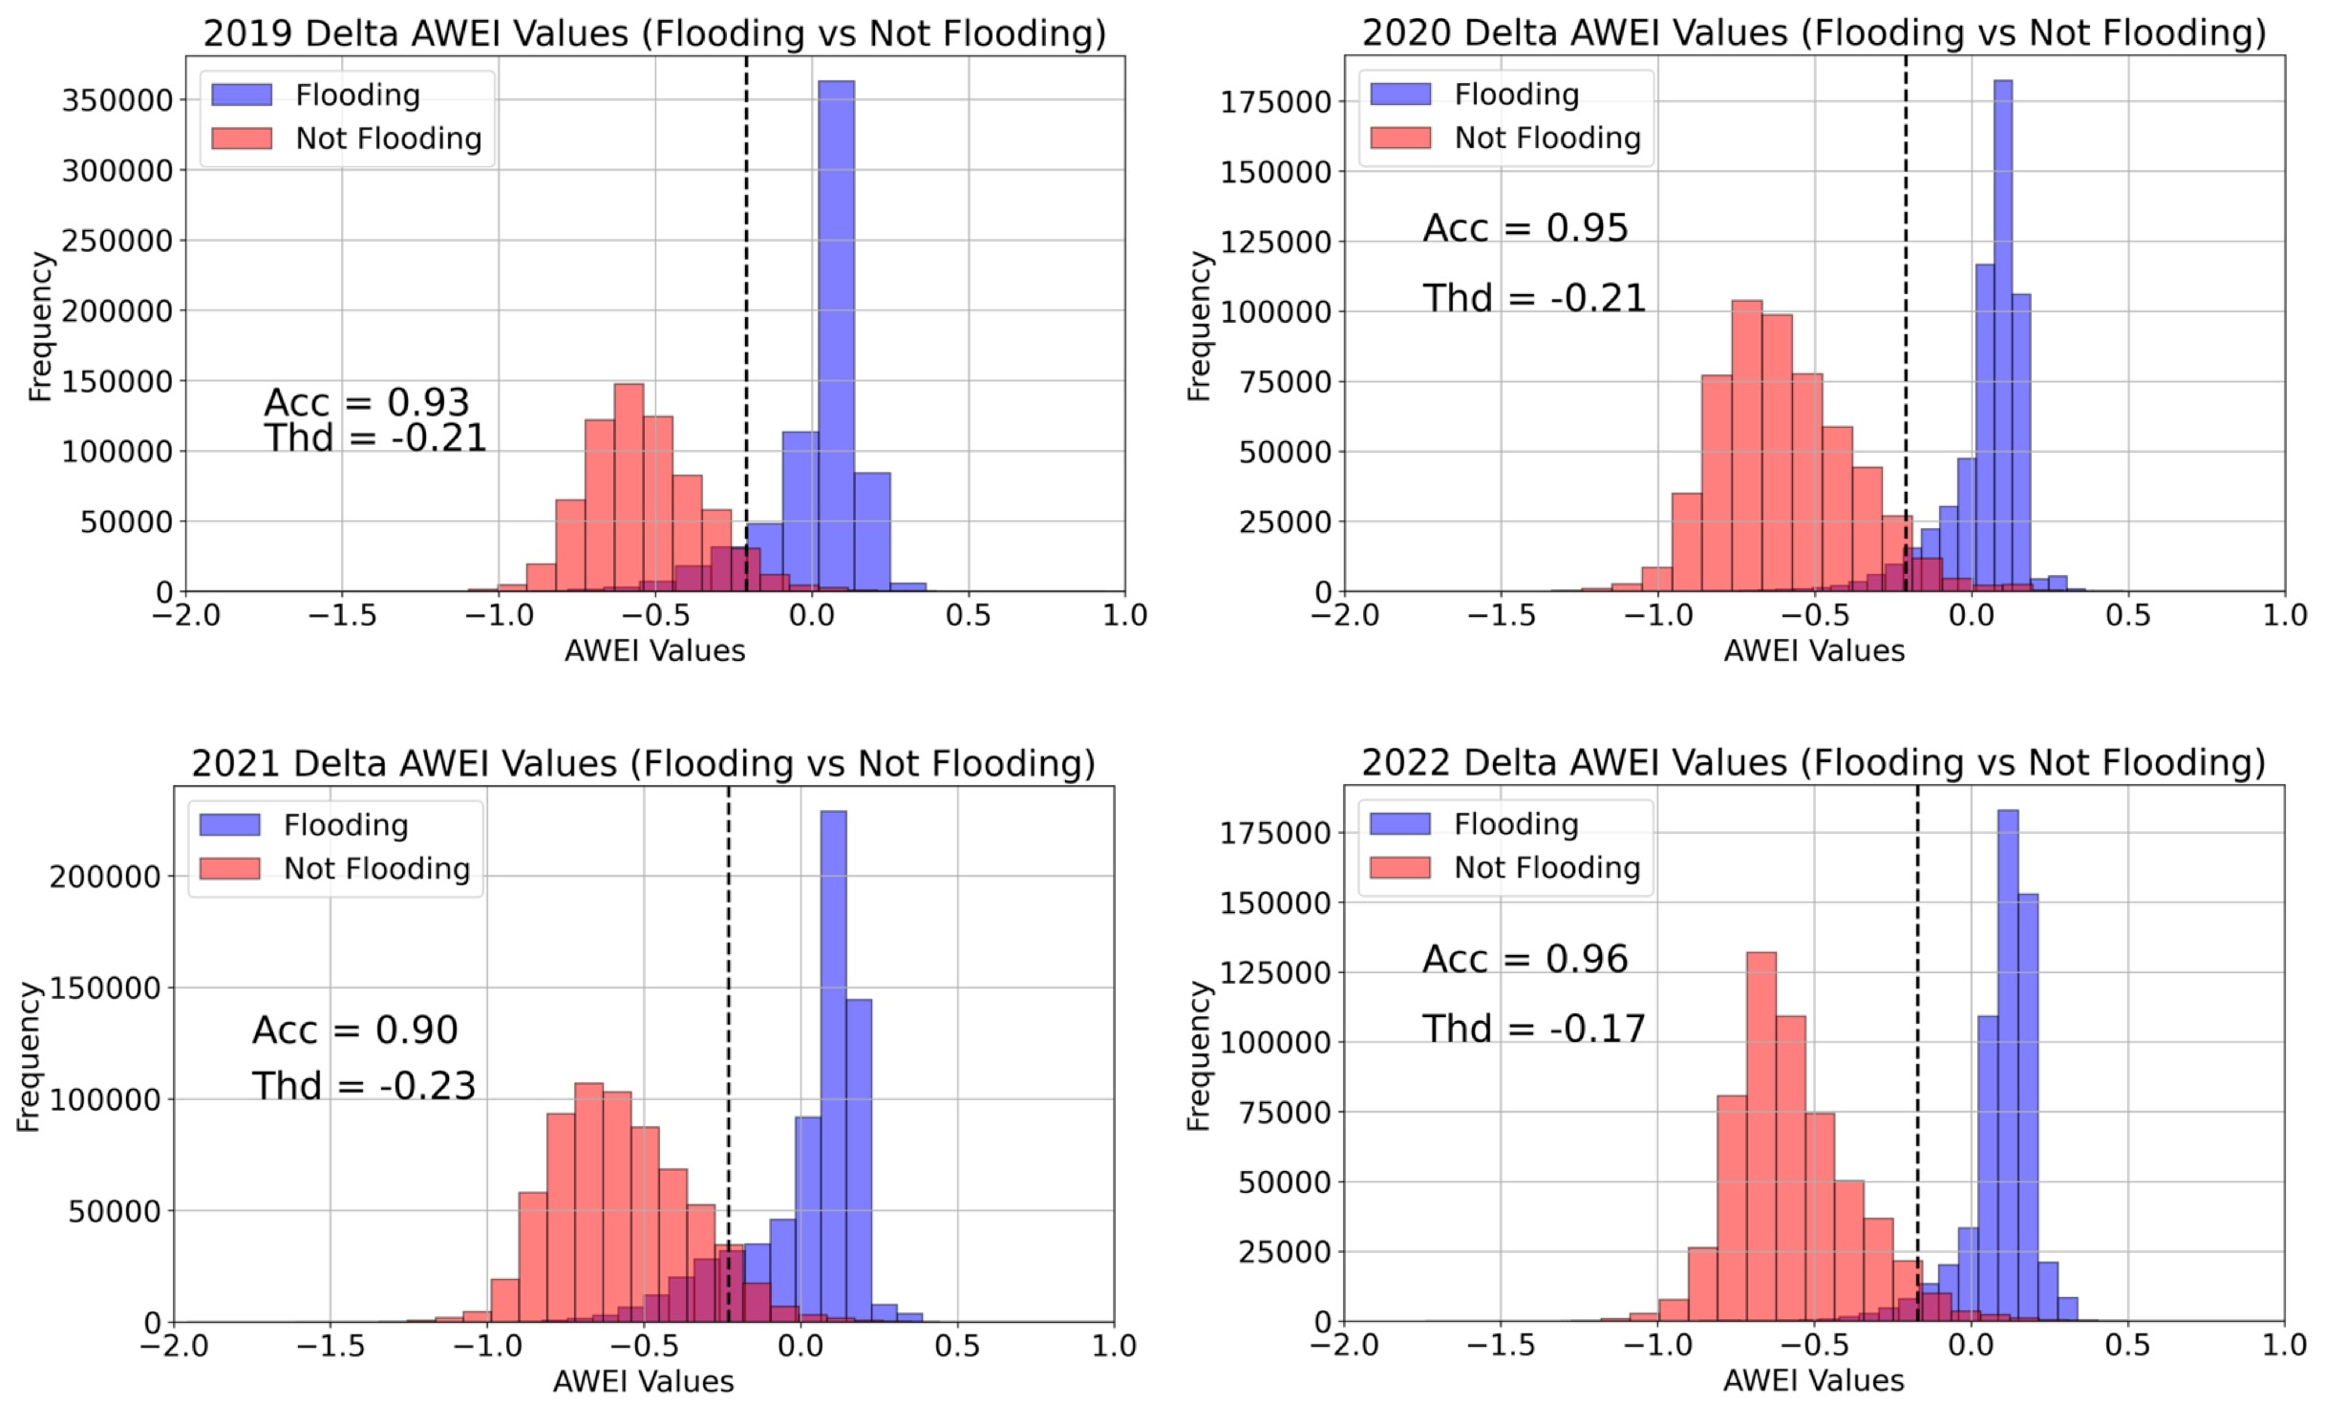
Figure A3. Flooding detection results using a thresholding approach based on AWEI for four years of spectroscopy-derived flooding products, showing both the detection accuracy (%) and the optimal threshold values.

Figure A4. (Left) Day of the year marking the first observed flooding within the study period. (Middle) Day of the year marking the last observed flooding within the study period. (Right) Total flooding duration (days).

Table A1. Crop Type and Vulnerable Period
 |  | Early Season  Vulnerable Period |  |  |  | Late Season  Vulnerable Period |  |  |  | Critical Period (days)
 |  | Start |  | End |  | Start |  | End |  | Early season
A: Perennial crop
 | Almonds | 11-Feb |  | 27-Oct |  |  |  |  |  | 14
 | Pistachios | 11-Feb |  | 27-Oct |  |  |  |  |  | 10
 | Walnuts | 6-Mar |  | 23-Oct |  |  |  |  |  | 10
 | Orchards | 11-Feb |  | 23-Oct |  |  |  |  |  | 4
 | Subtropical Trees | 2-Aug |  | 30-Sep |  |  |  |  |  | 14
 | Young Perennial | 11-Feb |  | 27-Oct |  |  |  |  |  | 14
 | B: Annual crop
 | Field and Grain | 1-Jul |  | 29-Sep |  |  |  |  |  | 2
 | Corn | 10-Apr |  | 30-Sep |  |  |  |  |  | 8
 | Cotton | 7-Apr |  | 27-Sep |  |  |  |  |  | 8
 | Cucurbits | 1-Apr |  | 30-May |  | 15-Oct |  | 30-Nov |  | 4
 | Rice | 1-May |  | 20-Sep |  |  |  |  |  | 8
 | Bean Dry | 8-May |  | 28-Aug |  |  |  |  |  | 1
 | Berries | 1-Jan |  | 30-Jul |  |  |  |  |  | 7
 | Lettuce | 15-Mar |  | 15-Oct |  |  |  |  |  | 1
 | Onions and Garlic | 15-May |  | 5-Jun |  | 16-Jun |  | 31-Aug |  | 25
 | Potatoes | 7-Mar |  | 20-Jul |  |  |  |  |  | 1
 | Tomatoes | 15-Mar |  | 30-May |  | 30-Sep |  | 30-Nov |  | 4
 | Safflower | 5-Apr |  | 23-Jul |  |  |  |  |  | 1
 | Sunflowers | 15-mar |  | 15-Oct |  |  |  |  |  | 1
 | Truck | 12-May |  | 27-Sep |  |  |  |  |  | 4
 | Alfalfa | 3-Aug |  | 29-Sep |  |  |  |  |  | 14
 | Pasture | 1-Jul |  | 29-Sep |  |  |  |  |  | 14
Source: CA Simulations of Evapotranspiration of Applied Water (CalSIMETAW) unit values and several online sources for the California vegetable planting calendar, which can help determine the start and end dates of the risk periods when crops are most vulnerable to waterlogging.

Abandonment rate = 1 – Harvested Acre/Planted Acre

