Understanding Water Rate Amid Drought: Descriptive Evidence from Selected Irrigation Districts in California (2006-2024)
Contributing Authors: Siddharth Kishore, J. Andres Morandé, Spencer Cole, Morgan Malone, Josué Medellín-Azuara, .... others interested.
Draft Updated on February 2026
Executive Summary
The availability of water for irrigation has changed the agricultural landscape by supporting food production and food security globally. This study documents the landscape of agricultural water rates and its trends in California, the largest and most diverse agricultural system in the US. We compiled water rates from individual irrigation districts in California’s Central Valley from 2006 to 2024, which overlaps with two multi-year droughts, to examine differences in agricultural water rates spatially and temporally.
Water rates for agricultural uses in the San Joaquin Valley and Tulare Lake Basin regions more than double during critical dry years relative to normal water years, while water rates in the Sacramento Valley generally remain relatively stable or even decline slightly during times of water stress. Agricultural water rates outside the Central Valley, particularly in coastal counties, south coast, and southern California, including Riverside and San Diego, are several fold higher than in the Central Valley, most likely due to tight competition for water from urban areas. Most irrigation water in the Central Valley is devoted to tree crops, and vineyards, followed by forage crops.

1. Introduction and Motivation
The availability of water for irrigation is a major determinant on crop production decisions. Similarly, affordability of water may affect water agencies and grower decisions on how to best manage water and land, particularly during droughts. California is a place of climate extremes and transitions from multi-year droughts to extreme wet periods. Climate change is likely to increase this volatility (Jessoe et al. 2021). This will most likely affect irrigation water demand and supply in California, the largest and most diverse agricultural system in the US (Turland et al. 2025; Bruno and Jessoe 2024). This study documents spatial and temporal trends in agricultural water rates in California. To understand how agricultural water rates vary spatially, and temporally considering data availability, we assembled water rates from individual irrigation districts in California’s Central Valley from 2006 to 2024 and other areas in the state with more limited data. Over the study period, we used publicly available water rates data from individual irrigation websites and agricultural water management plans. We aggregated this dataset of selected irrigation districts and other service agencies, that had both volume and price data available and found that water rates for agriculture in the southern San Joaquin Valley regions are more than double (or 153% higher) during critical dry years from normal water years, while water rates in the Sacramento Valley generally remain the same, or even decline slightly during times of water stress.
  - Water availability, affordability, and agricultural production
Agricultural water delivery organizations may revise the price of water prior to irrigation season, depending on the season, water use, and type of water year (dry, critically dry, below normal, normal, above normal, and wet) presumably to achieve water conservation goals, cover costs, and efficient land management. Water prices can be a significant driver of agricultural investment decisions. In practice, several irrigation districts in our study region charge growers much less for irrigation (e.g., Imperial Irrigation District charges only $20 per acre-foot, approximately 325,851 gallons). Growers may respond to increasing volumetric pricing by changing crop-specific water use intensity or by changing irrigated acreage. Growers in irrigation districts also can reduce uncertainties about water availability by using off-farm irrigation water from irrigation water delivery organizations. While irrigation district boundaries are vast overall, an important agricultural area exists outside water agency boundaries. Those not served by irrigation districts and outside district boundaries heavily relies on on-farm groundwater and to some in the case of dryland farming and precipitation (Lobell et al. 2007). The cost of water to growers outside irrigation districts may be affected by land quality, choice of irrigation technology, well depth, pumping costs, electricity prices, and the hydrologic characteristics of farmland, such as hydraulic conductivity and, depth-to-groundwater.
Irrigation district managers are tasked with monitoring surface water measurements and water pricing that affects water conservation and water scarcity. During periods of excess demand, economic theory and empirical applications suggest that water prices are bound by water scarcity and are increased by scarcity rent (Tsur and Dinar 1997). This is particularly true for agricultural users associated with perennial croplands in below-normal water years, and more so in critical dry years. Drought may reduce the ability of irrigation managers to deliver surface water and so increase uncertainty from water unavailability for growers.
  - California in the context of agricultural water rates
California’s agricultural water agencies provide water delivery services to a significant area of arable land. This water is from several sources with different costs, supporting all crops. To generate revenue from irrigation water deliveries to agricultural water users, water delivery organizations employ various water pricing approaches, including fixed (per-acre) assessments, volumetric (per acre-foot) pricing, and a combination of per-acre assessments and volumetric pricing approaches (Hrozencik et al. 2025).
California irrigation water delivery organizations offer this combination of both per-acre assessments and volumetric pricing, where growers pay fixed fees for each acre owned, and then per unit of water delivered fees. In California’s semi-arid Mediterranean climatic conditions and large irrigated cropped areas, irrigation water delivery can cost from $0 to more than $1,000 per acre-foot of surface water depending on hydrologic conditions (dry to wet) and locations (critically overdrafted basins to non-overdrafted basins). This huge variation in water prices can reflect variability in physical conditions (climate, soil properties, and water scarcity) as well as variability in the conveyance of water to agricultural users and water contracts (Tsur 2005).
The southern part of the San Joaquin Valley, which had 54% of the state’s 8.5 million acres irrigated farmland in 2018, has the highest prices between $200-$500 per acre-foot, and more in droughts. Water rates are generally less than $50 per acre-foot in the northern Central Valley (e.g., Sacramento Valley which has 21% of state irrigated farmland) and less than $1.00 per acre-foot in some districts of coastal region, which have less than 10% of California’s irrigated farmland (Peterson et al. 2023). Here we document water rates from selected irrigation districts in California.

  - Study objectives and scopes
This study has two main objectives: First, to comprehensively document water rates for commercial agriculture across space and over time; Second, to present a differentiated agricultural water rate by water year (normal year versus dry year).
- Institutional and Conceptual Background
  - How irrigation water is priced in practice
California’s irrigated agriculture relies primarily on surface water and groundwater extraction made available for agricultural growers at a cost through institutions like irrigation and water storage districts. These institutions were set up to provide water for agriculture. However, not all agricultural land is within the supply boundaries of irrigation districts, meaning some growers cannot be serviced. Growers within water district bounds are more water secure than those outside; growers without irrigation district access rely more on groundwater supplies.
Irrigation districts offer water to serviceable lands for a cost. These price is divided into two classifications discussed here as fixed and volumetric costs. Fixed rates are annual charges per acre of land a grower owns and potentially served by future water deliveries. This rate is charged regardless of whether water is eventually delivered. On the other hand, volumetric costs are charged by actual water delivery, usually per acre-foot (approximately 325,851 gallons) of water.
Volumetric water rates often change from year to year to reflect changes in water supply and demand. Periods of low supply, such as in droughts and drier years generally or wetter years with an excess of water may influence water prices that growers pay. So, water year characteristics may then influence overall costs and demands for agricultural production.
The UCLA Institute of the Environment and Sustainability and the Natural Resources Defense Council (NRDC) timely published a report detailing water rates for specifically the Lower Colorado River Basin States, including California (Garrison et al. 2025). According to the report, the cost of surface water at the wholesale level is free or nearly free for water districts, with major agricultural districts paying minimal or far less than municipalities using the same volume of water. Garrison et al. (2025) study notes that these prices are much lower and consequently weaken growers’ incentive to conserve and can accelerate existing water shortages. These costs reflect only the cost of water delivery and do not internalize the rent from the water scarcity, especially in dry years. In practice, districts can raise water prices in drier years to adjust for excessive water shortages during times of scarcity, deterring users from over-ordering water.
Water trading can assist in regulating water costs during periods of low supply (Bruno et al. 2024). With water trading, farmers who grow crops that are more profitable, such as perennial fruits and nuts, can purchase water from farmers growing less profitable crops (Hanak et al. 2023). While the state-wide standard on groundwater trading is generally no or local trading, recent studies (e.g., Hanak et al. (2023)) suggest different helpful water trading cases, including basin and valley trading.
In California’s irrigated agriculture, water rates are typically set by irrigation districts or groundwater extraction agencies to recover fixed infrastructure, operation, and administrative costs, rather than reflect real-time water scarcity, and are commonly assessed on a per-acre, per-acre-foot, or tiered volumetric basis. Rate setting is shaped by regulatory frameworks such as Proposition 218, which constrains public agencies to charging no more than the cost of service, and Sustainable Groundwater Management Act (SGMA), which authorizes groundwater sustainability agencies to levy fees for management and compliance but does not require scarcity-based pricing. Surface water rates therefore tend to remain stable across hydrologic conditions, while groundwater scarcity is signaled indirectly through higher pumping costs, declining well performance, or regulatory limits rather than through explicit price adjustments. Identifying changes in agricultural water rates as a signal of scarcity is a challenging task. Because drought-period rate increases can exacerbate farm income losses, raise equity concerns for smaller or junior users, and risk legal challenges under cost-of-service requirements, a tension highlighted in Hanak et al. (2014). For a water rate study, these regulatory constraints imply that rates alone provide a weak scarcity signal, and that financial sustainability and demand management must be evaluated jointly with allocations, pumping restrictions, and market-based instruments operating within California’s legal framework. As we only observe rates from publicly available documents, our analyses are limited to those rates in this document.
b. Groundwater substitution and off-water-agency farming
Groundwater extraction provides 30% to 40% of the water supply for irrigated agriculture in California during the normal water year, and this extraction can reach up to 60% to 70% during dry water years depending on surface water availability. Groundwater has long been the main buffer to cope with surface water shortage in dry years (Medellín-Azuara et al. 2024). In addition to that, there are areas not served by water agencies that primarily rely on groundwater, a source for irrigation. The cost of using groundwater is highly dependent on energy costs. Deeper groundwater tables, particularly during seasonal overpumping in dry years, may significantly increase the costs, particularly in overdrafted basins along with production economics and the agricultural system. The cost of pumping groundwater is the main component of water prices for areas irrigated using this scarce source (Moore et al. 1994). Due to the additional lift associated with pumping during dry years, the cost increased significantly, consequently resulting in unsustainable critically overdrafted basins. Appendix Figure A1 shows spatial variation and maps the extent of irrigated areas located outside water district boundaries.
- Data Sources and Study Areas
  - Sample selection and coverage
We compiled water rate information, including volumetric water rates and fixed water rates, for water years from 2006 to 2024 from multiple water irrigation districts website and publicly available agricultural water management plans (AWMPs) in seventeen counties of the Central Valley. In particular, we collected water rates observations from 128 water districts across space and time. Additionally, we collected agricultural water rate data from outside the Central Valley, particularly in coastal counties, the south coast, and southern California, such as Riverside, San Diego, and Imperial counties. Figure A2 presents a histogram showing the number of districts selected each year from 2006 to 2024.
During our study period (2006-2024), we estimated the reported irrigated area as covered by the selection of water districts across Central Valley is around 5.04 million acres, and the total irrigated acreage is 4.24 million acres. These values suggest that nearly 84% of all acres charged by irrigation districts were irrigated. The average annual water delivery is calculated to be 1.43 AF per acre, a range of 0.2 AF/acre to 4.7 AF per acre is observed during the study period. This range is the range of averages across districts during the study period. Appendix Table 1a and 1b provides the names of selected water districts and the year for which the water rate was collected.
  - Water-year classification
California classifies each water year as wet, above normal, below normal, dry, or critical dry based on runoff and snowpack indices that reflect both current hydrology and prior-year conditions, providing a standardized description of overall water availability (CDEC 2023). The classification is published annually by the California Department of Water Resources (CA-DWR), typically in winter and refined in spring, and is used to guide state water project allocations, reservoir operations, and regulatory requirements. Each water year signals the degree of scarcity or surplus facing water systems, influencing delivery reliability, environmental flow obligations, and drought response actions. The year type classification is relevant to this study as it allows us to differentiate water rates between normal and dry years. Following such classification, between 2006 and 2024, five critical dry years (2008, 2014, 2015, 2021, and 2022) were recorded in the Sacramento Valley, and seven critically dry years (2007, 2008, 2013, 2014, 2015, 2021, and 2022) were recorded in the San Joaquin Valley.
Methods and Metrics
  - Volumetric water rates
We collected data on both volumetric and fixed water rates for irrigable land from selected water districts, for which rates were publicly available during our study period either through published rates on each district’s website and/or their Agricultural Water Management Plans (AWMPs). Although in our analysis, we focus only on volumetric rates reported on the districts’ website or on their AWMPs, mainly to reflect on the cost of delivery and compare it during times of water stress relative to a normal water year. Volumetric rates capture the actual amount of water delivered, and the grower is charged on an acre-foot basis. Tables A1a and A1b in the Appendix present the data structure and water rate information individually at the water district level for both normal and dry years.
  - Weighted averages and aggregation
The weighted averages were calculated using total irrigated acres in each water district for the study year. In instances where the irrigated acreage was unknown, it was assumed to be the same as the known irrigated acreage for the same district in the nearest year. Individual agencies and districts manage water rates independently. For our purposes, we categorized the water districts into three regions: (1) Sacramento Valley; (2) San Joaquin Valley; and (3) Tulare Lake Basin. We combined the water year type classification with the estimated water rate information and grouped into dry and normal years. We then aggregated water districts in these three regions across our study period to calculate the total irrigated acres in normal and dry years. This will allow us to compare rates that vary widely across regions of somewhat heterogeneous hydrological basins.
  - What are we NOT estimating
First, we are not quantifying shadow prices or the forgone opportunity cost of water use. Block rates for volumetric water pricing are not available to the researchers from publicly available reports of water districts. We observed a single volumetric rate for a year in selected water districts. This observed volumetric rate masks block-rate heterogeneity and does not fully capture the final prices paid by the grower. Second, we are not estimating the marginal willingness-to-pay or sell among different water users. We lack information on water trade among water users or on inter-district water trade, which hinders estimating the marginal willingness to pay or sell water. Third, we cannot quantify relevant measures of water conservation effectiveness, particularly during drought. Fourthly, missing from this analysis is an examination of water flow requirements and their corresponding water prices during growing and non-growing seasons.
Quantifying these estimates, especially forgone opportunity cost of water, is crucial to understanding the causes of variations in agricultural water rates and their connection to water availability for allocation purposes. Unfortunately, the water districts data that we use is either one or multiple ad hoc years, and there is no other suitable publicly available dataset to quantify these estimates.
- Spatial Patterns in Agricultural Water Rates
  - Central Valley
In normal years, the selected water districts in the Sacramento Valley cumulatively serve/bill on average 491,543 acres but in dry years they can irrigate only 233,650 acres. Similarly, the Tulare Lake Basin includes on average 747,795 acres during normal years and 482,359 acres during the dry years for the selected water districts. This shows potential adaptation by idling fields and grain crops (Medellín-Azuara et al. 2022). In contrast, the San Joaquin Valley had served more acreage during dry years compared to normal years, with an average of 1,161,885 (999,388) acres in dry (normal) years. Further analysis of billed areas by crop types shows some interesting trends. The total water uses in San Joaquin Valley increased during dry years most likely because of the large new acreage of perennial crops such as tree crops and vineyards in the region over time until the latest drought. For example, agricultural land use for tree crops and vineyards served by the Arvin-Edison water storage district in Kern County increased from 49,650 acres in 2005 to 59,240 acres in 2017 (or 19.3%). During this period, the water applied to these crops rose from 291,370 acre-foot in 2005 to 356,663 acre-foot in 2017 (22.4%). The combined acreage of alfalfa crops and pasture in 2005 was 1,146 acres, but it increased to 7,026 acres in 2011, then decreased to 4,647 acres in 2017. The water use for alfalfa crops in that selected district was 21,857 acre-feet in 2005, but dropped to a little less than half to 12,078 acre-feet in 2017. This suggests that the acreage and water use of water-intensive crops and lower-value crops, such as alfalfa, increased over time until the recent drought in 2020-2022.
The total area receiving water deliveries from selected districts also decreased during dry years in the Sacramento Valley and Tulare Lake Basin regions.
Table 1 presents the weighted average agricultural surface water rates separately for the Sacramento Valley, San Joaquin Valley, and Tulare Lake Basin, and by normal and dry years. The district irrigated area weights were used for estimating the weighted mean water rates. We aggregated data across water districts for both normal and dry years to calculate the mean volumetric water rates in the Central Valley.
Table 1. Weighted Mean Agricultural Surface Water Rates for the Central Valley in Normal and Dry Years, 2006-2024
Variable | Total | Normal Year | Dry Year
A: Sacramento Valley
Volumetric water rate ($/AF) | 42.55 | 45.35 | 36.66
Number of districts | 26 | 18 | 8
B: San Joaquin Valley
Volumetric water rate ($/AF) | 66.00 | 49.46 | 90.84
Number of districts | 114 | 70 | 44
C: Tulare Lake Basin
Volumetric water rate ($/AF) | 149.66 | 82.92 | 241.34
Number of districts | 70 | 46 | 24
Note: Nominal dollars are reported. Mean water rates are calculated using weights. The weight for each district is calculated by dividing the irrigated area of that district by the total irrigated area in that region. Appendix Tables 1a and 1b present detailed water rates in both normal and dry years for selected water districts in the Central Valley.

In normal water years, agricultural water rates range from $40 per acre-foot to $150 per acre-foot on average across the Central Valley selected districts. Specifically, at $43 per acre-foot, the Sacramento Valley’s average water rate has the lowest average cost, followed by the San Joaquin Valley’s $66 per acre-foot, and the highest in the Tulare Lake Basin region at $150 per acre-foot. During dry years, the volumetric water price in the Sacramento Valley slightly decreases by $5 per acre-foot from $43 per acre-foot to $38 acre-foot. Surprisingly, volumetric water prices in San Joaquin Valley also decreases by approximately 24% (from $76 per acre-foot in normal years to $58 per acre-foot in dry years). In contrast, volumetric water prices in the Tulare Lake Basin region more than doubled (or 153%), from $112 per acre-foot in normal years to $283 per acre-foot in dry years.
We note an increase in the average water rates from the northern part of the Central Valley to the southern part of the Central Valley, with the weighted mean volumetric water rate being $43/AF in the Sacramento Valley to $92/AF and $148/AF in the San Joaquin Valley and Tulare Lake Basin, respectively. The water rate in the southern part of the Central Valley increases in dry water years by 23% to more than 150%, relative to normal water years. The water rate in the southern part of the Central Valley significantly increases in dry years, from 23% to more than 151%, compared to normal water years. Specifically, the weighted mean volumetric water rate in the San Joaquin Valley increases by $19 per acre-foot during dry years, which is a 23% increase, compared to the weighted mean of $82 per acre-foot during normal years. In the Tulare Lake Basin, the increase is significant at $241/AF during dry years compared to $91/AF in normal water years (a 165% increase). Tables 1a and 1b present detailed water rates in both normal and dry years for selected water districts in the Central Valley.
Figure 1 shows map of agricultural average volumetric water rates per acre-foot of water by irrigation district during both normal and dry years in California. Normal years have a wide range of water rates between $2.42 and $739, in contrast with the water rate during dry years ranging from $0.80 to $937.50. Additionally, normal years have a concentration of higher rates in the Southern Central Valley counties of Fresno, Tulare, Kings, and Kern, and slightly lower rates in the northern part of the Valley. Modesto Irrigation District, which services areas of Stanislaus County, has the lowest volumetric rate during dry years, at $2.42 per acre-foot of water. The irrigation district that offers the highest water prices during non-dry years is Dudley Ridge Water District, servicing portions of Fresno and Kings Counties at a rate of $739 per acre-foot. The rates in the dry years follow a similar pattern, with lower prices in the north, and higher prices in the southern portion of the Central Valley. Modesto Irrigation District has the lowest average rate, at a mere $0.80 per acre-foot, while Orange Cove Irrigation District, spanning areas in Fresno and Tulare Counties, has the highest rates, at $937.50 per acre-foot.
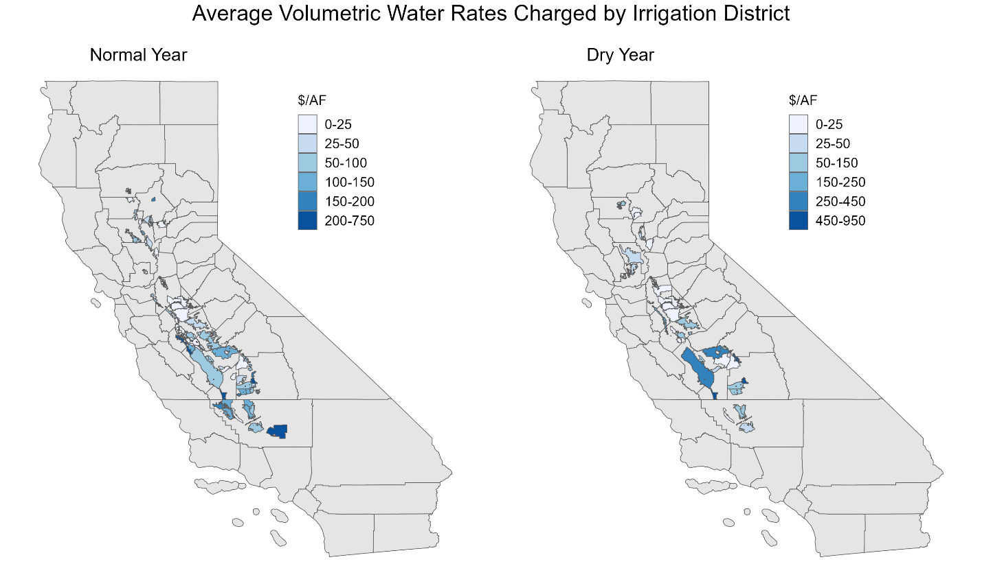
Figure 1. Comparison of weighted mean volumetric water rates among California Irrigation Districts during both normal and dry years
Note: The weighted averages of the volumetric water rates were calculated using total irrigated acres in each water district for the study year. Appendix Figure A3 shows the volumetric water rates for the subsample between 2014 and 2024.

As mentioned, water rates in the Central Valley increase from the northern part of the Valley to the southern part. Water rates increase dramatically during dry years, particularly in the San Joaquin Valley and Tulare Lake Basin regions. The use of agricultural land in recent years has shifted to higher value and sometimes higher water use perennial crops. The higher water rates in these regions may be offset by the revenue from high-value crops. Water delivery is agnostic to agricultural land use at the user's end. Lower-value forage crops have the same water rate as high-value tree crops and vineyards.
Table 2 presents the crop types and mean irrigated cropped area for selected water districts in Kern, Kings, Fresno, and Tulare counties.
Table 2. Mean Irrigated Cropped Area and Crop Type for selected water districts in Kern, Kings, Fresno, and Tulare counties
 | Forage Crop | Tree Crop and Vineyards | Vegetables and Non-Fruit Trees | Other
A: All years
Mean irrigated area (acre) | 12,322  (20.6%) | 31,994  (59.0%) | 15,124  (10.4%) | 11,386  (16.2%)
Number of districts | 42 | 45 | 33 | 39
B: Normal year
Mean irrigated area (acre) | 11,782  (21.8%) | 30,804  (56.7%) | 13,208  (10.1%) | 11,705  (18.0%)
Number of districts | 25 | 27 | 21 | 23
C: Dry year
Mean irrigated area (acre) | 13,114  (18.9%) | 33,779  (62.6%) | 18,478  (11.0%) | 10,927  (13.8%)
Number of districts | 17 | 18 | 12 | 16
Note: Percentage is reported in parentheses. To calculate the percentage, we divide the crop type by the total area of irrigated cropped crops. Forage crops refer to corn, alfalfa, and pasture. The irrigation districts were selected from Kern, Kings, Fresno, and Tulare counties from 2006 to 2024. Appendix Tables 2a and 2b present detailed crop types that were irrigated in both normal and dry years for selected water districts in the southern Central Valley.

Most agricultural land use is for tree crops and vineyards in both normal and dry years (56.7% in normal year vs. 62.6% in dry year), followed by forage crops (21.8% in normal year vs. 18.9% in dry year). Figure 2 provides a visual representation of the data. The districts that grow the highest acreage of forage crops are Lower Tule River Irrigation District, which serves Tulare County, with 70% of the districts’ applied water going to forage crops during normal years. Importantly, there is a decrease in the number of districts providing water for forage crops during dry years.
Tree crops and vineyards see their highest acreage in Dudley Ridge Water District in Fresno County, with 100% of their water allocated for tree and vine crops, which remain constant during the dry years. Vegetable and non-tree fruit crops are grown the most in Westland Water District of Fresno County, with 42% of their irrigated crops falling in this category. There is a significant decrease in the number of districts providing water for vegetables and non-fruit tree crops during dry years.

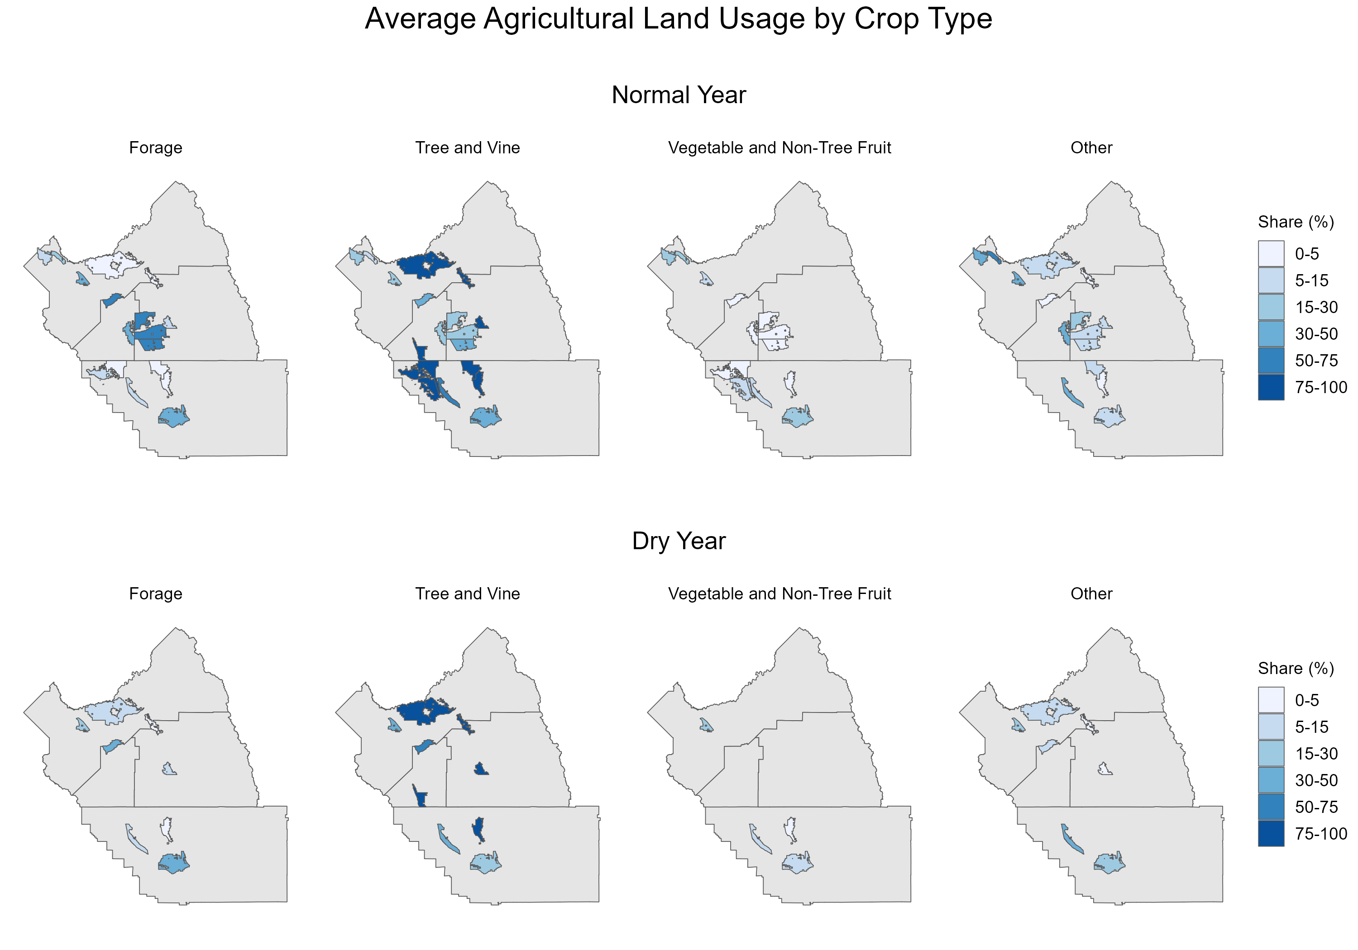
Figure 2. Average agricultural land use by crop type within four counties in Kern, Kings, Fresno, and Tulare counties by irrigation district.
Note: We categorize all reported crop types into four groups. Forage crops include alfalfa, corn, and assorted grains, grasses, and pasture. Tree and Vine include fruit and nut trees and grapes. Vegetables and Non-Tree Fruits include berries, cucurbits, truck crops, and melons. The Other category includes cotton, flowers and nursery, sod, and all other crops which irrigation districts categorized as “other” themselves, often crops that make up less than 5% of the district’s total cropland.

  - Quartile analysis
Table 3 presents the quartile analysis of agricultural volumetric water rates. Based on water rates, we disaggregated the sample into four quartiles: Q1 (0 - 25 pct), Q2 (25 pct - 50 pct), Q3 (50 pct - 75 pct), and Q4 (75 pct - 100 pct).
Panel A of Table 3 presents the quartile analysis for the Sacramento Valley. Q1 and Q3 have 7 irrigation districts, while Q2 and Q4 districts have 6 districts each. The weighted mean water rates vary from $8/AF for districts associated with Q1 to $81/AF associated with districts in Q4. Q1 districts irrigated a cumulative total of 225,003 acres, while Q4 districts irrigated a cumulative total of 551,944 acres.
Panel B of Table 3 presents the quartile analysis for the San Joaquin Valley. The number of districts in the San Joaquin Valley is much higher compared to the Sacramento Valley and Tulare Lake Basin, with 36 districts associated with Q1 and 28 districts associated with Q4.
Table 3. Quartile Analysis of Agricultural Water Rates
Quartile | Number of Districts  (Count) | Weighted Mean  ($/AF) | Total Irrigated Agriculture Area  (Acre)
A: Sacramento Valley
Q1 (0 - 25 pct) | 7 | 7.88  [4.00,13.00] | 225,003
Q2 (25 pct – 50 pct) | 6 | 20.23  [15.15,28.20] | 175,537
Q3 (50 pct – 75 pct) | 7 | 41.18  [30.00,51.85] | 237,673
Q4 (75 pct – 100 pct) | 6 | 81.19  [60.00,152.46] | 551,944
B: San Joaquin Valley
Q1 (0 - 25 pct) | 36 | 5.23  [0.00,16.00] | 2,945,609
Q2 (25 pct – 50 pct) | 21 | 18.92  [16.14,24.25] | 2,360,312
Q3 (50 pct – 75 pct) | 29 | 51.33  [25.25,73.00] | 2,041,867
Q4 (75 pct – 100 pct) | 28 | 206.13  [74.00,937.50] | 2,390,786
C: Tulare Lake Basin
Q1 (0 - 25 pct) | 18 | 24.50  [0.00,47.00] | 1,002,872
Q2 (25 pct – 50 pct) | 17 | 65.47  [49.50,75.50] | 1,401,735
Q3 (50 pct – 75 pct) | 18 | 104.61  [80.00,145.50] | 2,811,506
Q4 (75 pct – 100 pct) | 17 | 377.63  [149.23,825.00] | 3,040,084
Note: Square brackets report the price range with its minimum and maximum at each quartile level. Mean volumetric water rates are calculated using weights. The weight for each district is calculated by dividing the irrigated area of that district by the total irrigated area in that region.

The volumetric water rate in Q3 and Q4 quartiles of districts in the San Joaquin Valley are higher than those in the Sacramento Valley, but they are less than those in all quartiles when compared to the Tulare Lake Basin. Specifically, the weighted mean water rates vary between $6/AF for districts in Q1 to $242/AF for districts in Q4. The San Joaquin Valley has about 114 irrigation districts, serving the largest agricultural area with cumulative total coverage of approximately 3 million acres in Q1 districts and 2.4 million acres in Q4. Importantly, Q1 districts that charge relatively very low prices (mean water rate is $5/AF) serve 3 million acres, while Q4 districts that charge $239/AF serve approximately 2.4 million acres.
Finally, Panel C of Table 3 presents the quartile analysis for the Tulare Lake Basin. Q1 is associated with 18 districts while Q4 is associated with 17 districts. On average, Q1 districts variable charge is $24/AF, while Q4 districts volumetric charge is $377/AF. Q1 and Q2 districts in the Tulare Lake Basin serve cumulative total agricultural areas of approximately 1 million acres and 1.4 million acres, respectively. While Q3 and Q4 districts serve a cumulative total agricultural area of approximately 2.8 million acres and 3 million acres, respectively. Importantly, Q4 districts in Tulare Lake Basin charge on average the largest water price in the Central Valley, $377/AF, to a cumulative total of 3 million agricultural areas.
  - Beyond Central Valley
Water rates in agricultural regions out the Central Valley also vary widely and are often times priced significantly higher during drought, relative to water prices within the Central Valley (Table 4).
Table 4. Agricultural Water Rates in Selected Counties Outside the Central Valley
Region | Water District | Volumetric Water Rate ($/AF)
Northern Areas | Butte Valley Irrigation District | 29.50
 | Montague Water Conservation District | 125.00
 | Tulelake Irrigation District | 50.00
Coastal Counties | California Water Service Company - Salinas | 1682.56
 | Marina Coast Water District | 1589.94
 | Pajaro Valley Water Management Agency | 392.00
South Coast | Calleguas Municipal Water District | 1,146.00
 | Camrosa Water District | 0.01
 | Oxnard City | 0.002
 | Ventura County | 1,635.68
Riverside | Coachella Valley Water District | 34.32
 | Fallbrook Public Utilities District | 1,730.27
 | Rancho California Water District | 0.01
 | Western Municipal Water District | 0.06
San Diego | San Diego County Water Authority | 1,205.00
 | Valley Center Municipal Water District | 1,879.53
 | Yuima Municipal Water District | 1,641.04
Imperial | Imperial Irrigation District | 20.00
Note: We compiled water rate information from the websites of individual water irrigation districts for 2023.

Water rates for agriculture in San Diego County were $1,666 per acre-foot, on average. It is important to note that major agricultural users may use municipal water, which includes storage, treatment, and reliability fees, for agricultural purposes. Therefore, readers must be cautious in interpreting these water rates. Moreover, the average agricultural water rate in other counties such as Monterey, a high-value vegetable and berry growing county, is $1,221 per acre-foot. In Ventura, a subtropical fruit tree growing county, charges $709 per acre-foot. Selected water districts in Riverside County charge $441 per acre-foot for agricultural water. Siskiyou, Imperial, and Santa Cruz counties charge $68, $20, and less than $1 per acre-foot, respectfully.
To sum up, water rates outside the Central Valley, particularly in coastal counties, south coast, and southern California, including Riverside and San Diego, are many times higher than in the Central Valley, most likely due to tight competition for water from urban municipalities. Second, and most importantly, growers in these counties receive water deliveries that are probably treated, reliable municipal water, which has relatively higher water prices compared to water rates from agricultural water districts.
- Temporal Patterns and Drought Response
  - Trends by water year and region
Figure 3 shows regional trends in volumetric water rates during our study period for the aggregate of selected water districts in the Central Valley. Water prices in normal years vary between $6/AF and $365/AF, while dry years have prices ranging from $30/AF to $615/AF. The water rates in the Sacramento Valley overall increased from $6 per acre-foot in 2006 to $80 per acre-foot in 2017, with some declines in 2015 and 2020 (Figure 3: Upper Left Panel). Water rates in the San Joaquin Valley also increased, with spikes in 2009 and 2002, following critical dry years in 2008 and 2021 (Figure 3: Upper Right Panel). In the San Joaquin Valley and Tulare Lake Basin, the water rates are much higher than the Sacramento Valley. The Tulare Lake Basin has also had an overall increase in water rates, with spikes occurring in critical dry years in 2013 and 2021 (Figure 3: Lower Left Panel).
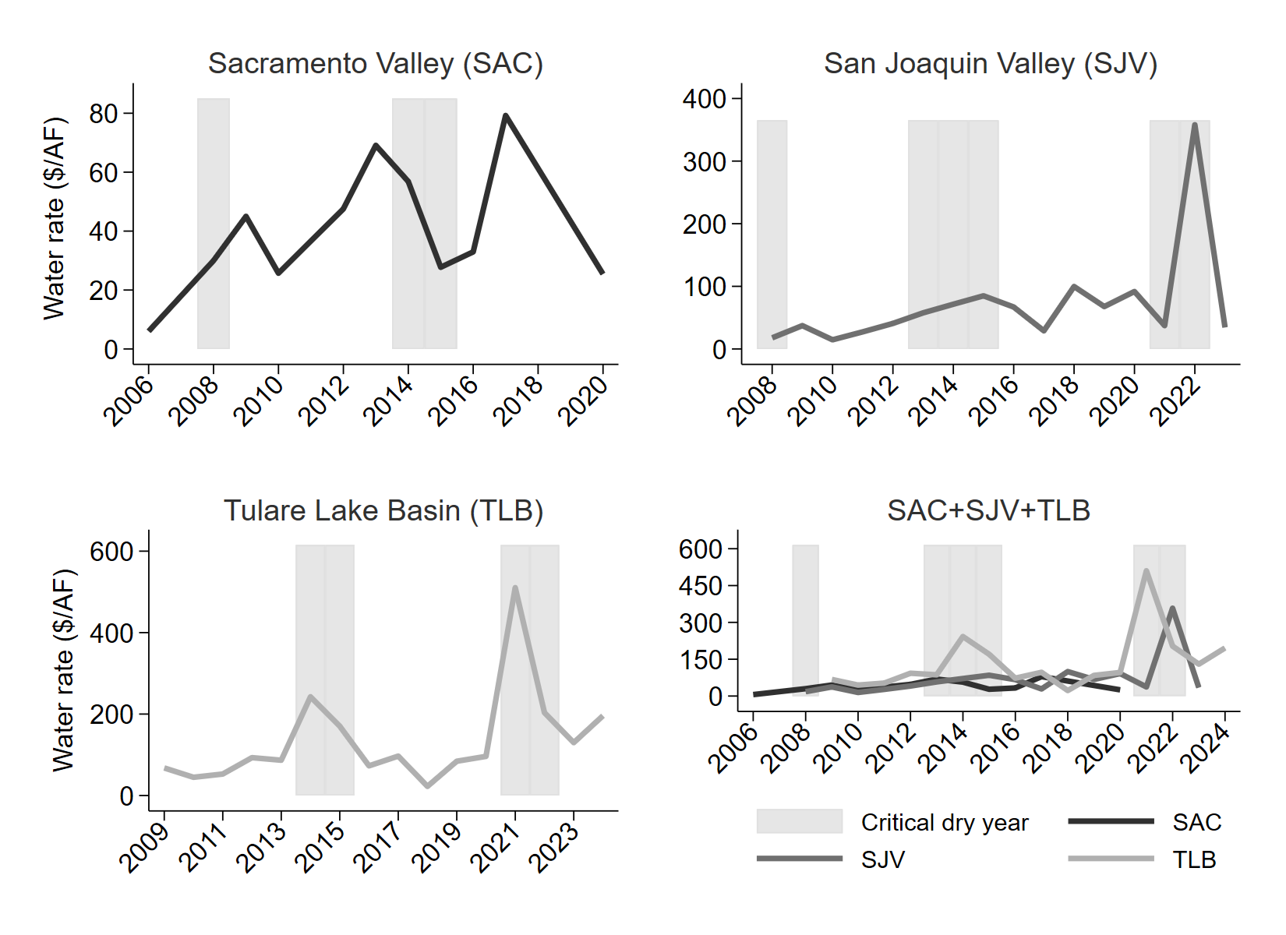
Figure 3. Trends in Water Rates by Year and Region: Sacramento Valley (upper left panel), San Joaquin Valley (upper right panel), Tulare Lake Basin (lower left panel), and combined region (lower right panel)
Note: The figures show the recent trends in weighted mean volumetric water rates (solid line). We aggregated water rates ($/AF) for irrigation districts over water years by regions. In the background of the graphs, we highlight the critical dry years in California: 2008, 2014, and 2015 in Sacramento Valley; 2008, 2013, 2014, 2015, 2021, and 2022 in San Joaquin Valley; and 2014, 2015, 2021, and 2022 in Tulare Lake Basin.

  - Water rates decline over dry years
We propose two explanations, both related to the dataset used for analysis of why some regions had declining rates in dry years. First, due to the data aggregation based on region and water year type. That is, not all water districts have available data for all years during our study period. Some irrigation districts have available data during normal years but have relatively low water rates. This could also explain high fluctuations in water rates in both normal and dry years. Secondly, several water districts gradually change their water rates annually. Although most of the costs are fixed, whether it is dry or normal, growers still have to pay those fixed costs. This suggests that there could be a smaller difference in water rates between normal and dry years. Next, we show the water applied to irrigated agriculture by hydrological region and year.
  - Water supply in Central Valley
Water sources for agriculture in the Central Valley, such as the Sacramento River, San Joaquin River, and Tulare Lake region, vary widely by hydrological region. Yet these sources can be broadly classified into project water (Central Valley Project or State Water project), groundwater extraction, local supplies, and other sources (e.g., imports, recycling, reuse, desalination, etc.).
Figure 4 shows the applied water in agriculture by three hydrological region: Sacramento River, San Joaquin River, and Tulare Lake region. Over the years, there has been a decrease in project water sources for all three regions, particularly for Tulare Lake, and as a result, groundwater extraction has increased significantly. Local supplies have remained stable for the Sacramento River and somewhat stable for the San Joaquin River, but have fluctuated in Tulare Lake, with a significant decline in recent years. Groundwater extraction, especially in Tulare Lake and the San Joaquin River, increased significantly during the 2012-2016 drought and the more recent 2020-2022 drought in the Central Valley.

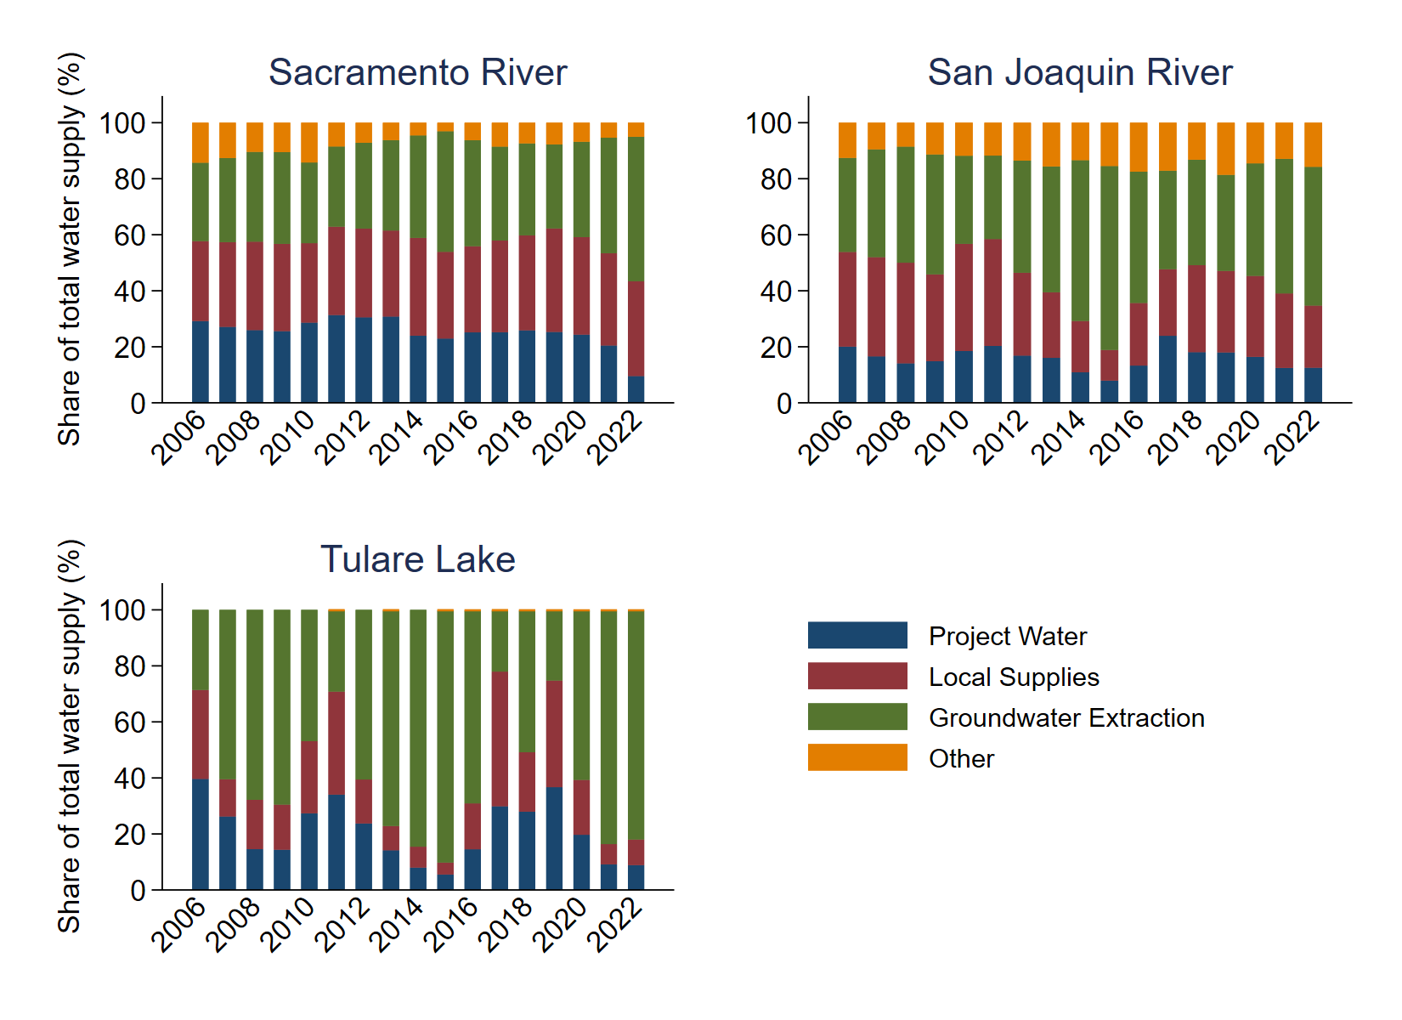
Figure 4. Applied Water in Irrigated Agriculture by Region and Year
Source: California Department of Water Resources (CA-DWR) water balance data from 2006 to 2022.
Note: The share of water supplied is calculated by dividing the amount of water supplied per four supplier types and the total water supplied for a year in that hydrological region. The share of water supplied adds to 100% each year.

- Interpretation and Implications
  - What do estimated rates capture?
Volumetric water rates may partially capture the spatial and/or temporal pattern of water scarcity depending on season, water use, and type of water year. In practice, the costs can also represent the difference in conveyance and infrastructure costs for water delivery in surface water. The differences in water delivery between normal and dry years may be due to the energy and capital costs of pumping in groundwater extraction. An example of a differing volumetric pricing schedule in California is in Turlock Irrigation District (TID), where the price per acre-foot varies across time, season, and land class (e.g., water right seniority, land quality, farm location, etc.), and total quantity delivered within a given unit of time, with marginal increases in price for larger quantities of water demanded. TID fixed rates for irrigable land, scheduled for 2025, during normal and dry years are $60 fee per acre and $68 fee per acre, respectively, representing an increase of 13.3% in dry years relative to normal years. In addition to the fixed fee rates, TID charges volumetric rates based on tiers: $2.70 per acre-foot for Tiers 1- 3, and $20 per acre-foot for Tier 4.
  - Implications for drought resilience and land use
There are two important observations for agricultural land use in the Central Valley. First, the gradual transition from annual crops to perennial crops brings in systemwide constraints and sometimes higher consumptive demands. Second, agricultural lands with water-intensive higher-value crops can increase water use intensity, particularly during drought, most likely due to increased drought-induced evapotranspiration. The water rate has not been adequately raised to capture rent from scarcity.
Taken together, these have important implications for adapting to effective drought resiliency.
- Limitations and Directions for Future Research
This document cannot examine the reason why water rates differ due to data limitations. As in much research, perfect data is non-existent and water rates data is particularly scant. Not all information about water uses and agricultural land use in the irrigation district across years is available. Additionally, water rates for selected water districts are available for random ad hoc years. This data constraint makes it difficult to formalize tables and compare water rates at the water district level. We address this issue by aggregating water rates at the higher unit of measurement for three regions: Sacramento Valley, San Joaquin Valley, and Tulare Lake Basin. This attempt to increase sample size to include data from 2006 creates limitations. The aggregation over 19 years is likely to complicate the explanation of how differences could be attributed to weather (dry versus normal). First fundamental changes in cropping activities over 19 years. Second, the year-to-year changes in economic factors that influence production decisions. Nonetheless, this document can be used as a basis for further research work.
We highlight important points for future research:
1. Access to irrigation water reduces crop vulnerability to purely hydrologic drought by decoupling production from short-term precipitation variability, although it does not eliminate exposure to heat stress or longer-term water supply limits.
2. Water-intensive and higher-value crops have increased water use intensity (acre-foot per acre), particularly during drought, most likely from higher drought-induced evapotranspiration, while the water rate does not internalize this scarcity and has stagnated
3. Agricultural land not served by water agencies is more likely to fallow/idle land in drought.
4. Water agencies are challenged with covering costs, and balancing between water availability and affordability
- Conclusions
This study examines the spatiotemporal trends in agricultural water rates for selected irrigation districts in the Central Valley from 2006 to 2024. During this period, five critically dry years occurred in the northern Central Valley, and seven critical dry years occurred in the southern Central Valley. Compared to the northern region, the southern region of the Valley supports more agricultural areas with water-intensive crops and with prices for water irrigation more than double, on average –$92/AF to $148/AF, compared to $43/AF. These higher agricultural water rates in the southern Central Valley during drought partially capture the greater cost of water scarcity. The price of water does not fully internalize the full social, economic, and environmental costs and benefits of water use.
Agricultural water prices are relatively lower for most of the price ranges throughout our study region, and consequently, water prices are undervalued, which raises concern about the lack of incentives to conserve water. Importantly, most water districts allocate water to agricultural land uses with water-intensive and more profitable crops which could suggestively harden water demands. Drought can disrupt agricultural systems; however, irrigation can somewhat mitigate negative effects on agricultural productivity. Although growers pay little or no money for water, any significant changes in water prices could have an impact on agricultural land use. As water for farmland irrigation becomes more expensive, more farmlands may be fallowed and or repurposed, potentially resulting in less local food production. While low water prices for irrigation help keep agricultural viability, among other factors of crop production and market forces, increased flexibility to incorporate scarcity is in place to potentially increase drought resilience and a future area of research.

References
Bruno, Ellen M., and Katrina Jessoe. 2024. “Designing Water Markets for Climate Change Adaptation.” Nature Climate Change 14 (4): 331–39. https://doi.org/10.1038/s41558-024-01964-w.
Bruno, Ellen M., Katrina K. Jessoe, and W. Michael Hanemann. 2024. “The Dynamic Impacts of Pricing Groundwater.” Journal of the Association of Environmental and Resource Economists 11 (5): 1201–27. https://doi.org/10.1086/728988.
CDEC. 2023. “CDEC Water Year Type Dataset.” https://data.cnra.ca.gov/dataset/8f7c9792-652a-4f5e-95ad-707961dfc3f5/resource/da64051a-7751-48e1-ab59-39c73a3ea52d/download/cdec-water-year-type-nov-2023.xlsx.
Garrison, Noah, Mark Gold, Mackenzie Van Valkenburgh, and Isabel Friedman. 2025. “Wholesale Water Pricing in the Lower Colorado River Basin States.” Instititute of the Environment & Sustainability.
Hanak, Ellen, Andrew Ayres, Caitlin Peterson, Alvar Escriva-Bou, Spencer Cole, and Zaira Joaquín. 2023. “Managing Water and Farmland Transitions in the San Joaquin Valley.” Public Policy Institute of California.
Hanak, Ellen, Brian Gray, Jay Lund, et al. 2014. “Paying for Water in California.” Public Policy Institute of California.
Hrozencik, R Aaron, Nicholas A. Potter, and Steven Wallander. 2025. “Irrigation Organizations: Water Measurement and Pricing (Report No. EB-40).” U.S. Department of Agriculture, Economic Research Service, February.
Jessoe, Katrina, Pierre Mérel, and Ariel Ortiz–Bobea. 2021. “Chapter 16. Climate Change and California Agriculture.” University of California: Giannini Foundation and Division of Agriculture and Natural Resources.
Lobell, David B., Kimberly Nicholas Cahill, and Christopher B. Field. 2007. “Historical Effects of Temperature and Precipitation on California Crop Yields.” Climatic Change 81 (2): 187–203. https://doi.org/10.1007/s10584-006-9141-3.
Medellín-Azuara, Josué, Alvar Escriva-Bou, Amélie C. M. Gaudin, Kurt A. Schwabe, and Daniel A. Sumner. 2024. “Cultivating Climate Resilience in California Agriculture: Adaptations to an Increasingly Volatile Water Future.” Proceedings of the National Academy of Sciences 121 (32): e2310079121. https://doi.org/10.1073/pnas.2310079121.
Medellín-Azuara, Josué, Alvar Escriva-Bou, José M Rodríguez-Flores, et al. 2022. “Economic Impacts of the 2020–22 Drought on California Agriculture.” A Report for the California Department of Food and Agriculture. Water Systems Management Lab. University of California, Merced 35p.
Moore, Michael R., Noel R. Gollehon, and Marc B. Carey. 1994. “Multicrop Production Decisions in Western Irrigated Agriculture: The Role of Water Price.” American Journal of Agricultural Economics 76 (4): 859–74. https://doi.org/10.2307/1243747.
Peterson, Caitlin, Alvar Escriva-Bou, Josué Medellín-Azuara, and Spencer Cole. 2023. “Water Use in California’s Agriculture.” Public Policy Institute of California, April.
Tsur, Yacov. 2005. “Economic Aspects of Irrigation Water Pricing.” Canadian Water Resources Journal 30 (1): 31–46. https://doi.org/10.4296/cwrj300131.
Tsur, Yacov, and Ariel Dinar. 1997. “The Relative Efficiency and Implementation Costs of Alternative Methods for Pricing Irrigation Water.” World Bank Economic Review 11 (2): 243–62.
Turland, Madeline, Colin A. Carter, Bulat Gafarov, Jens Hilscher, and Katrina Jessoe. 2025. “Price Sensitivity to Precipitation and Water Storage in California.” Nature Sustainability 8 (12): 1505–12. https://doi.org/10.1038/s41893-025-01659-w.

Appendix Figures and Tables
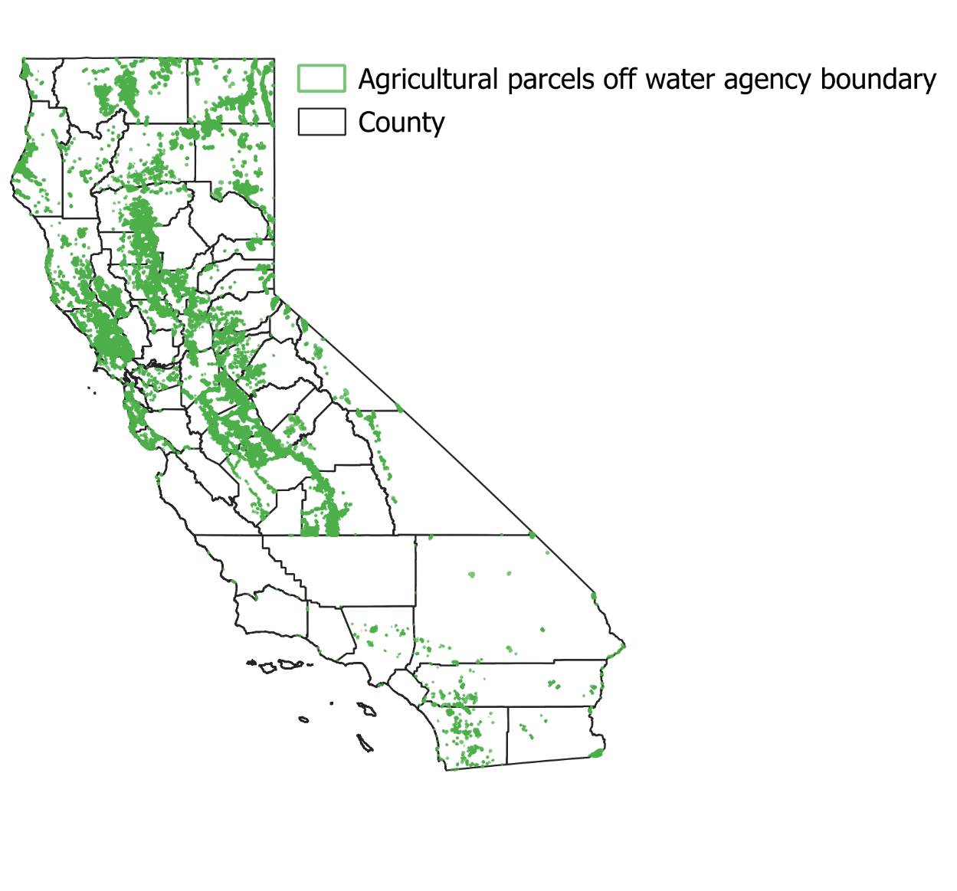
Figure A2. Agricultural parcels located outside water agency (special district) boundaries
Source: Author’s estimation using agricultural parcels from the 2018 LandIQ and the water district shapefile from the California Department of Water Resources.
Note: The figure shows agricultural parcels as polygons. The boundaries of the county are represented by dark solid lines.
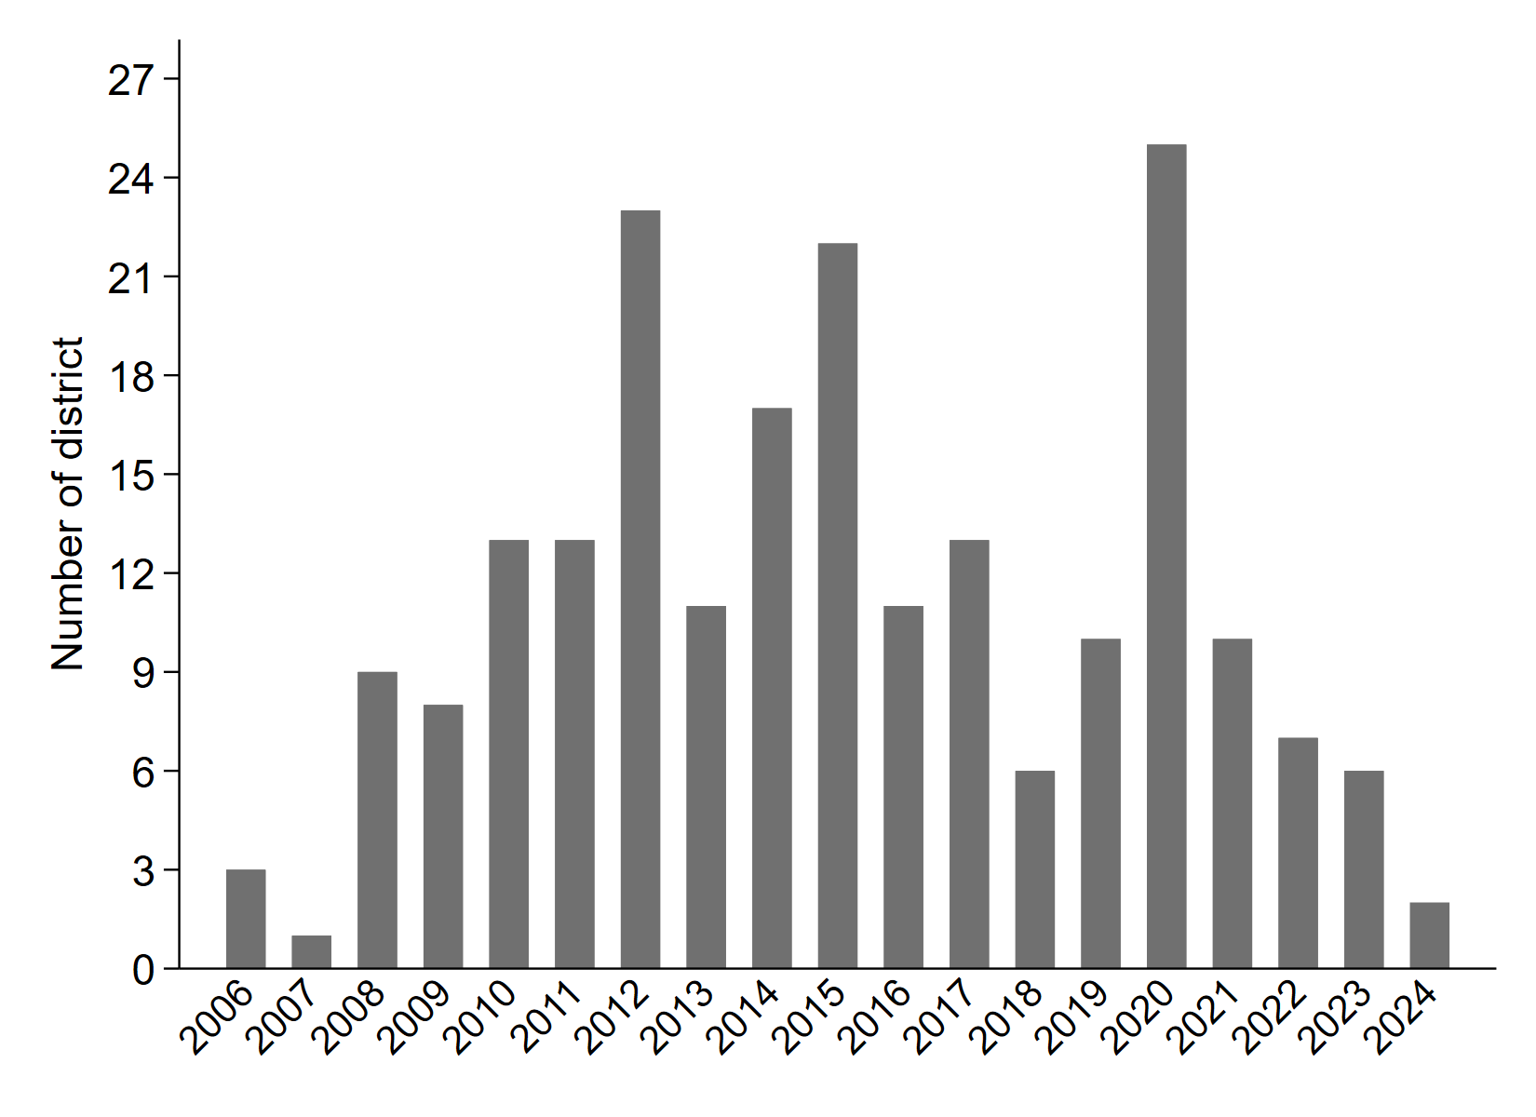
Figure A2. Histogram of the selected district and year
Note: The x-axis represents the study period between 2006 and 2024. The y-axis represents the selected sample in terms of the number of districts used in our analysis for each year. The range is from 1 district in 2007 to 25 districts in 2020.

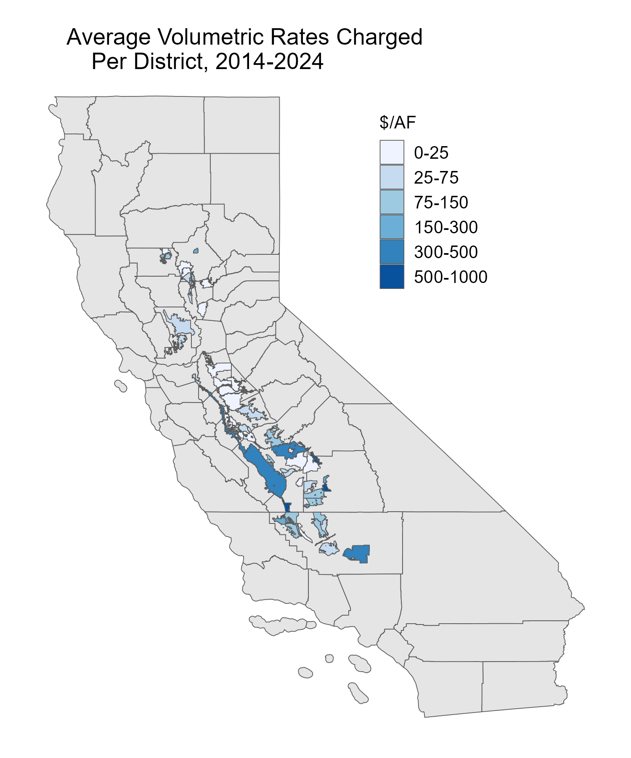

Figure A3. Volumetric water rate, 2014-2024
Note: This figure shows the volumetric water rates that are charged by district on average between 2014-2024. Across the study region, the lowest observed water price is $4.00/acre-foot, charged by the Western Canal Water District in Glenn County. On the other hand, Orange Cove Irrigation District, which serves areas in Fresno and Tulare Counties, charges the highest, at $937.50/acre-foot of water.

Table A1a. Water District Rates in Normal Year
Region | County | Water Districts | Volumetric Water Rate ($/AF) | Fixed Water Rate ($ per acre) | Billed Irrigated Area (Acre)
A: Sacramento Valley (SAC)
SAC | Butte | Paradise Irrigation District [2017] | 152.46 | 210.65 | 11,377
SAC | Butte | Biggs - West Gridley Water District [2020] | 25.41 | 2.00 | 24,745
SAC | Butte | Butte Water District [2016] | 50.00 | 5.00 | 13,562
SAC | Colusa | Westside Water District [2010] | 25.72 | 20.23 | 14,775
SAC | Colusa | Colusa County Water District [2013] | 69.10 | 31.75 | 39,391
SAC | Colusa | Reclamation District No. 108 [2012] | 15.15 | 16.80 | 47,990
SAC | Colusa | Reclamation District No 1004 [2012] | 10.75 | 16.80 | 20,885
SAC | Glenn | Glenn - Colusa Irrigation District [2012] | 70.55 | 7.63 | 141,612
SAC | Glenn | Orland Unit Water Users Association [2017] | 13.00 | 37.50 | 12,578
SAC | Glenn | Provident Irrigation District [2012] | 60.00 | 2.00 | 20,561
SAC | Glenn | Princeton - Codora - Glenn Irrigation District [2012] | 8.00 | 18.00 | 11,454
SAC | Sacramento | Natomas Central Mutual Water Company [2012] | 7.10 | 85.57 | 18,413
SAC | Shasta | Clear Creek Community Services District [2012] | 51.85 | 183.46 | 4,046
SAC | Solano | Maine Prairie Water District [2006] | 6.00 | 6.00 | 33,621
SAC | Sutter | Meridian Farms Water Company [2012] | 120.00 | 22.00 | 9,092
SAC | Sutter | Sutter Mutual Water Company [2012] | 33.00 | 33.00 | 46,296
SAC | Tehama | Corning Water District [2009] | 45.00 | 17.81 | 7,338
SAC | Yuba | Browns Valley Irrigation District [2016] | 16.20 | 16.40 | 13,807
B: San Joaquin Valley (SJV)
SJV | Fresno | James Irrigation District [2009] | 90.00 | 0.00 | 23,874
SJV | Fresno | Firebaugh Canal Company [2011] | 23.25 | 0.00 | 21,761
SJV | Fresno | Orange Cove Irrigation District [2009] | 77.00 | 67.00 | 27,557
SJV | Fresno | Panoche Water District [2012] | 148.50 | 15.92 | 37,436
SJV | Fresno | Laguna Irrigation District [2017] | 12.50 | 24.50 | 29,210
SJV | Fresno | Fresno Irrigation District [2018] | 150.00 | 43.50 | 151,943
SJV | Fresno | Dudley Ridge Water District [2020] | 739.00 | 0.00 | 20,976
SJV | Madera | Madera Irrigation District [2019] | 84.21 | 15.00 | 207,131
SJV | Madera | Root Creek Water District [2016-2020, 2023] | 113.20 | 0.00 | 87,174
SJV | Madera | Gravely Ford Water District [2009] | 40.00 | 5.00 | 7,672
SJV | Madera | Columbia Canal Company [2011, 2012] | 33.75 | 50.00 | 30,806
SJV | Madera | Chowchilla Water District [2009] | 54.00 | 16.00 | 6,500
SJV | Merced | San Luis Water District [2011, 2020] | 271.58 | 4.70 | 63,943
SJV | Merced | San Luis Canal Company [2011, 2012, 2016-2020, 2023] | 62.52 | 26.00 | 336,487
SJV | Merced | Central California Irrigation District [2023] | 17.00 | 0.00 | 143,000
SJV | Merced | Grassland Water District [2011, 2012, 2016, 2017, 2019, 2020, 2023] | 16.00 | 16.00 | 13,080
SJV | Merced | Merced Irrigation District [2010-2012, 2016-2020] | 35.45 | 24.00 | 800,712
SJV | San Joaquin | Woodbridge Irrigation District [2011, 2012, 2016-2020, 2023] | 21.35 | 21.35 | 99,328
SJV | San Joaquin | Byron Bethany Irrigation District [2017] | 65.00 | 120.00 | 10,500
SJV | San Joaquin | South San Joaquin Irrigation District [2020] | 6.50 | 24.00 | 51,000
SJV | Stanislaus | Turlock Irrigation District [2010-2012, 2017] | 15.65 | 34.00 | 584,058
SJV | Stanislaus | Oakdale Irrigation District [2011, 2020] | 19.12 | 30.00 | 126,857
SJV | Stanislaus | Modesto Irrigation District [2006, 2009-2012, 2020] | 2.42 | 29.00 | 399,037
SJV | Stanislaus | West Stanislaus Irrigation District [2011] | 60.00 | 20.00 | 20,155
SJV | Stanislaus | Patterson Water District [2010] | 30.00 | 60.00 | 12,792
C: Tulare Lake Basin (TLB)
TLB | Fresno | Westlands Water District [2012] | 86.29 | 8.14 | 357,868
TLB | Fresno | Riverdale Irrigation District [2016] | 27.00 | 27.00 | 13,173
TLB | Fresno | Tranquility Irrigation District [2009] | 65.00 | 7.50 | 8,596
TLB | Kern | North Kern Water Storage District [2016, 2020] | 125.95 | 0.00 | 125,617
TLB | Kern | Tehachapi - Cummings County Water District [2019] | 491.67 | 491.67 | 1,951
TLB | Kern | Semitropic Water Storage District [2020] | 86.62 | 0.00 | 127,035
TLB | Kern | Cawelo Water District [2020] | 75.50 | 75.50 | 34,728
TLB | Kern | Lost Hills Water District [2012, 2020] | 134.19 | 21.29 | 56,962
TLB | Kern | Kern Delta Water District [2019, 2020] | 73.50 | 7.80 | 190,283
TLB | Kern | Southern San Joaquin Municipal Utility District [2019, 2020] | 130.00 | 65.00 | 92,734
TLB | Kern | Buena Vista Water Storage District [2011, 2016-2020] | 16.92 | 32.33 | 194,622
TLB | Kern | Shafter-Wasco Irrigation District [2020, 2023] | 113.02 | 109.11 | 60,063
TLB | Kern | Arvin-Edison Water Storage District [2006, 2011, 2017] | 67.90 | 61.51 | 338,434
TLB | Kern | Belridge Water Storage District [2012, 2020] | 134.43 | 118.23 | 85,980
TLB | Kern | Berrenda Mesa Water District [2012, 2020] | 188.25 | 16.05 | 51,605
TLB | Tulare | Stone Corral Irrigation District [2010] | 103.00 | 40.18 | 5,904
TLB | Tulare | Terra Bella Irrigation District [2010] | 59.34 | 96.00 | 12,739
TLB | Tulare | Delano-Earlimart Irrigation District [2009] | 69.00 | 42.15 | 19,066
TLB | Tulare | Alta Irrigation District [2010] | 4.10 | 19.95 | 28,571
TLB | Tulare | Lower Tule River Irrigation District [2016, 2020] | 80.00 | 34.72 | 84,169
TLB | Tulare | Exeter Irrigation District [2020] | 155.00 | 30.00 | 12,700
TLB | Tulare | Saucelito Irrigation District [2010] | 55.00 | 10.00 | 20,115
TLB | Tulare | Alpaugh Irrigation District [2024] | 175.00 | 18.00 | 10,000
TLB | Tulare | Ivanhoe Irrigation District [2010] | 55.00 | 27.00 | 10,879
TLB | Tulare | Lindmore Irrigation District [2024] | 205.00 | 205.00 | 23,345
TLB | Tulare | Tulare Irrigation District [2010, 2012, 2020] | 32.24 | 32.00 | 169,251
TLB | Tulare | Porterville Irrigation District [2010] | 50.00 | 29.00 | 12,672
TLB | Tulare | Pixley Irrigation District [2017] | 103.50 | 42.49 | 110,464
Note: Mean values are reported for volumetric and fixed water rates, along with summarized values for irrigation acres. The year of the report is presented in square brackets. We compiled water rate information from individual water irrigation district websites between 2006 and 2024 across Central Valley.

Table A1b. Water District Rates in Dry Year
Region | County | Water Districts | Volumetric Water Rate ($/AF) | Fixed Water Rate ($ per acre) | Billed Irrigated Area (Acre)
A: Sacramento Valley (SAC)
SAC | Butte | Richvale Irrigation District [2015] | 18.00 | 11.00 | 22,329
SAC | Butte | Western Canal Water District [2015] | 4.00 | 5.00 | 43,376
SAC | Glenn | Orland - Artois Water District [2014] | 125.00 | 24.94 | 28,673
SAC | Solano | Solano Irrigation District [2015] | 47.04 | 47.04 | 42,000
SAC | Sutter | South Sutter Water District [2014] | 10.75 | 10.75 | 42,385
SAC | Sutter | Sutter Extension Water Districts [2015] | 28.20 | 28.20 | 17,546
SAC | Sutter | Feather Water District [2008] | 30.00 | 70.00 | 7,398
SAC | Yolo | Yolo County Flood Control and Water Conservation District [2015] | 42.00 | 105.00 | 29,943
B: San Joaquin Valley (SJV)
SJV | Fresno | Orange Cove Irrigation District [2015] | 937.50 | 73.00 | 25,796
SJV | Fresno | Fresno Irrigation District [2013, 2022] | 334.16 | 45.00 | 282,706
SJV | Fresno | Consolidated Irrigation District [2015] | 23.00 | 25.30 | 119,259
SJV | Fresno | James Irrigation District [2014] | 131.00 | 21.00 | 23,874
SJV | Fresno | Laguna Irrigation District [2021] | 49.00 | 25.00 | 29,210
SJV | Fresno | Dudley Ridge Irrigation District [2015] | 485.00 | 0.00 | 23,010
SJV | Madera | Root Creek Water District [2021, 2022] | 119.76 | 119.76 | 29,058
SJV | Merced | San Luis Canal Company [2013-2015, 2021, 2022] | 71.60 | 28.20 | 210,520
SJV | Merced | Merced Irrigation District [2013-2015, 2021] | 62.05 | 24.00 | 400,475
SJV | Merced | Grassland Water District [2014, 2015, 2021, 2022] | 16.00 | 16.00 | 7,265
SJV | San Joaquin | Stockton East Water District [2015] | 14.03 | 14.03 | 58,113
SJV | San Joaquin | Banta-Carbona Irrigation District [2013] | 33.00 | 14.00 | 14,696
SJV | San Joaquin | South San Joaquin Irrigation District [2013-2015] | 3.00 | 24.00 | 159,000
SJV | San Joaquin | West Side Irrigation District [2008] | 14.00 | 90.00 | 5,722
SJV | San Joaquin | Woodbridge Irrigation District [2013-2015, 2021, 2022] | 21.03 | 21.03 | 61,280
SJV | Stanislaus | Del Puerto Water District [2008, 2014] | 219.40 | 20.00 | 70,709
SJV | Stanislaus | Turlock Irrigation District [2015, 2021] | 7.00 | 64.00 | 290,543
SJV | Stanislaus | Oakdale Irrigation District [2014] | 6.25 | 27.00 | 64,724
SJV | Stanislaus | Modesto Irrigation District [2007, 2008, 2013-2015] | 1.00 | 64.00 | 290,543
C: Tulare Lake Basin (TLB)
TLB | Kern | Semitropic Water Storage District [2013, 2015] | 95.00 | 117.00 | 257,057
TLB | Kern | Buena Vista Water Storage District [2013-2015] | 14.00 | 26.00 | 129,748
TLB | Kern | Kern-Tulare Water District [2008, 2014, 2021] | 286.00 | 99.00 | 58,296
TLB | Kern | Arvin-Edison Water Storage District [2022] | 123.00 | 150.00 | 105,894
TLB | Kern | Kern Delta Water District [2014] | 41.00 | 8.00 | 92,000
TLB | Kern | Cawelo Water District [2014, 2015] | 51.00 | 0.00 | 69,456
TLB | Kern | North Kern Water Storage District [2013, 2015] | 143.00 | 0.00 | 120,672
TLB | Tulare | Lindsay-Strathmore Irrigation District [2021] | 113.00 | 24.00 | 12,306
TLB | Tulare | Delano-Earlimart Irrigation District [2014, 2015] | 625.00 | 73.00 | 98,030
TLB | Tulare | Lower Tule River Irrigation District [2008] | 55.00 | 15.00 | 84,169
TLB | Tulare | Alta Irrigation District [2015] | 5.00 | 0.00 | 28,571
TLB | Tulare | Lindmore Irrigation District [2014] | 825.00 | 25.00 | 23,345
TLB | Tulare | Pixley Irrigation District [2008] | 64.00 | 68.00 | 59,283
Note: Mean values are reported for volumetric and fixed water rates, along with summarized values for irrigation acres. The year of the report is presented in square brackets. We compiled water rate information from individual water irrigation district websites between 2006 and 2024 across Central Valley.

Table A2a. Irrigated Cropped Area and Crop Type in Normal Year
County | Water District | Forage Crop | Tree Crop and Vineyards | Vegetables and Non-Fruit Trees | Other
Kern | Arvin-Edison Water Storage District | 5837  (5.1%) | 55762  (49.2%) | 37575  (33.1%) | 14228  (12.5%)
 | Belridge Water Storage District |  | 35158  (94.9%) | 1886  (5.1%)
 | Berrenda Mesa Water District | 2019  (7.7%) | 23909  (90.7%) | 424  (1.6%)
 | Buena Vista Water Storage District | 3314  (10.1%) | 16614  (50.4%) | 1710  (5.2%) | 11310  (34.3%)
 | Cawelo Water District | 77  (0.2%) | 32899  (95.8%) | 241  (0.7%) | 1131  (3.3%)
 | Kern Delta Water District | 20891  (30.7%) | 24068  (35.4%) | 14137  (20.8%) | 8854  (13.0%)
 | Lost Hills Water District | 1100  (3.7%) | 28593  (96.1%) | 75  (0.3%)
 | North Kern Water Storage District | 596  (1.2%) | 46626  (94.0%) | 1480  (3.0%) | 879  (1.8%)
 | Semitropic Water Storage District | 22095  (17.4%) | 84137  (66.4%) | 13201  (10.4%) | 7261  (5.7%)
 | Shafter-Wasco Irrigation District | 1537  (5.3%) | 24015  (82.5%) |  | 3554  (12.2%)
 | Southern San Joaquin Municipal Utility District | 1757  (3.9%) | 38715  (85.1%) |  | 5026  (11.0%)
 | Tulare Lake Basin | 30625  (31.2%) | 60  (0.1%) | 15200  (15.5%) | 52125  (53.2%)
 | Wheeler Ridge-Maricopa Water Storage District | 3502  (4.0%) | 71163  (81.1%) | 9669  (11.0%) | 3442  (3.9%)
Kings | Corcoran Irrigation District | 15514  (38.8%) | 8576  (21.4%) | 1094  (2.7%) | 14830  (37.1%)
 | Lakeside Irrigation District | 13710  (58.0%) | 6314  (26.7%) | 657  (2.8%) | 2940  (12.4%)
Fresno | Dudley Ridge Water District |  | 15858  (100.0%)
 | Firebaugh Canal Company | 4376  (20.1%) | 2155  (9.9%) | 3930  (18.1%) | 11300  (51.9%)
 | Fresno Irrigation District | 6250  (5.0%) | 105810  (84.2%) |  | 13551  (10.8%)
 | James Irrigation District | 7467  (33.7%) | 3543  (16.0%) | 2938  (13.3%) | 8182  (37.0%)
 | Laguna Irrigation District | 16624  (58.8%) | 10943  (38.7%) | 91  (0.3%) | 626  (2.2%)
 | Orange Cove Irrigation District | 940  (3.5%) | 25504  (95.6%) |  | 229  (0.9%)
 | Panoche Water District | 3172  (7.5%) | 10925  (25.9%) | 9245  (22.0%) | 18764  (44.6%)
 | Westland Water District | 47872  (12.3%) | 105879  (27.3%) | 162069  (41.8%) | 72194  (18.6%)
Tulare | Lindmore Irrigation District | 1461  (6.6%) | 17600  (79.0%) |  | 3219  (14.4%)
 | Lower Tule River Irrigation District | 38518  (70.3%) | 10908  (19.9%) | 150  (0.3%) | 5239  (9.6%)
 | Pixley Irrigation District | 19219  (58.8%) | 11239  (34.4%) | 100  (0.3%) | 2147  (6.6%)
 | Tulare Irrigation District | 26090  (51.7%) | 14732  (29.2%) | 1494  (3.0%) | 8189  (16.2%)
Note: Percentage is reported in parentheses. To calculate the percentage, we divide the crop type by the total area of irrigated cropped crops. Forage crops refer to corn, alfalfa, and pasture.

Table A2a. Irrigated Cropped Area and Crop Type in Dry Year
County | Water District | Forage Crop | Tree Crop and Vineyards | Vegetables and Non-Fruit Trees | Other
Kern | Buena Vista Water Storage District | 4238  (14.9%) | 9533  (33.6%) | 2031  (7.2%) | 12556  (44.3%)
 | Cawelo Water District | 163  (0.5%) | 32853  (98.1%) | 489  (1.5%)
 | Kern Delta Water District | 27961  (45.6%) | 12407  (20.2%) | 9194  (15.0%) | 11797  (19.2%)
 | Kern-Tulare Water District | 320  (1.8%) | 17468  (95.6%) | 279  (1.5%) | 208  (1.1%)
 | North Kern Water Storage District | 1633  (3.5%) | 40523  (87.9%) | 991  (2.1%) | 2967  (6.4%)
 | Semitropic Water Storage District | 53985  (37.8%) | 64497  (45.2%) | 4994  (3.5%) | 19355  (13.6%)
 | Shafter-Wasco Irrigation District | 2242  (7.9%) | 19018  (67.1%) |  | 7102  (25.0%)
 | Tulare Lake Basin | 29500  (45.6%) | 20  (0.03%) | 12300  (19.0%) | 22900  (35.4%)
 | Wheeler Ridge-Maricopa Water Storage District | 3031  (3.6%) | 66202  (78.2%) | 12117  (14.3%) | 3295  (3.9%)
Kings | Lakeside Irrigation District | 15273  (68.9%) | 5176  (23.4%) | 531  (2.4%) | 1185  (5.3%)
Fresno | Dudley Ridge Water District |  | 15880  (100.0%)
 | Fresno Irrigation District | 8699  (7.0%) | 100899  (80.8%) |  | 15321  (12.3%)
 | James Irrigation District | 4912  (20.6%) | 8127  (34.0%) | 4486  (18.8%) | 6349  (26.6%)
 | Laguna Irrigation District | 11449  (40.2%) | 15224  (53.5%) |  | 1783  (6.3%0
 | Orange Cove Irrigation District | 589  (2.3%) | 24634  (95.5%) |  | 573  (2.2%)
 | Westland Water District | 56797  (14.0%) | 107544  (26.5%) | 172879  (42.6%) | 68783  (16.9%)
Tulare | Delano-Earlimart Irrigation District | 725  (1.4%) | 47808  (94.9%) | 1444  (2.9%) | 380  (0.8%)
 | Lindmore Irrigation District | 1423  (6.5%) | 20216  (92.2%) |  | 284  (1.3%)
Note: Percentage is reported in parentheses. To calculate the percentage, we divide the crop type by the total area of irrigated cropped crops. Forage crops refer to corn, alfalfa, and pasture.

The author uses agricultural water districts and irrigation districts interchangeably to refer to water districts that are categorized for agricultural purposes throughout the paper.
A blogpost on California’s agricultural water prices is available at https://aquaoso.com/blog/california-agricultural-water-prices/
The classification for dry years was obtained at https://cdec.water.ca.gov/reportapp/javareports?name=WSIHIST. Water year classifications include wet, above and below normal, dry, and critical dry year types. We code critical dry years as dry and wet, above and below normal, and dry years as non-dry or normal years.
Two irrigation districts, Laguna and Turlock, both have in place volumetric rates in terms of whether or not it is a categorically normal or dry year, and these rates do not shift year-to-year. To account for this in these and other calculations, 2017 and 2021 were used to represent normal and dry years, respectively.
The Sacramento Valley comprises counties such as Butte, Colusa, Glenn, Sacramento, Shasta, Solano, Sutter, Tehama, and Yuba. The San Joaquin Valley consists of counties such as Fresno, Madera, Merced, San Joaquin, and Stanislaus. The Tulare Lake Basin consists of Kern, Tulare, and two irrigation districts in Fresno County.
Irrigation rates are available at https://www.tid.org/irrigation/irrigation-rates/

